# **Machine Learning and AI Foundations: Producing Explainable AI (XAI) and Interpretable Mach**

<https://trevorhastie.github.io/ISLR/>

https://corels.eecs.harvard.edu/

### **Exploring the world of explainable AI and interpretable machine learning**

Selecting transcript lines in this section will navigate to timestamp in the video

- [Keith] As data scientists and machine learning practitioners, we have to keep up to speed on the latest techniques. Increasingly, that means mastering algorithms that produce black box models. They can be a very powerful option, but with that power there's an extra burden placed on us. Hi, I'm Keith McCormick, and I want to invite you to join me as we explore the world of explainable AI and interpretable machine learning. I've been building predictive models with statistics and machine learning for 25 years now. Explainable AI is a new but critical addition to our skill set as predictive modelers. We stay focused on tabular data. We're going to define key terms, discuss strategy, explore the latest techniques and then demonstrate those techniques using the KNIME Analytics Platform. We have a lot to explore, so let's begin.

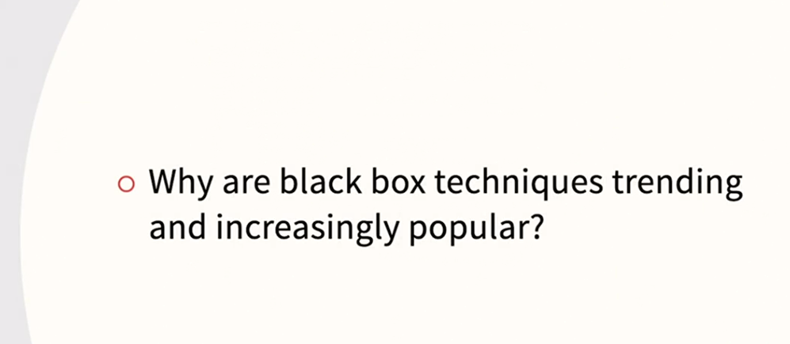

### **Target audience**

Selecting transcript lines in this section will navigate to timestamp in the video

- [Instructor] So who is this course designed for? If you are a data science and machine learning practitioner and you are trying to decide whether to use an interpretable machine learning model or a black box model combined with XAI, this course is for you. Also, we'll be using structured data. With structured data, you truly have a choice between interpretable and black box. XAI can also be applied to text and images, but we won't explore examples like that in this course. If you build models and you're not even sure of the relevant terminology, this course is also for you because we will start the discussion from scratch. However, there are two audiences that might be better served by taking another course first. If you are a non-technical senior executive and you are more interested in a high level overview, you might want to consider Aki Ohashi's very good Learning XAI course right here in the library. Also, if you're an absolute beginner when it comes to machine learning, and you have no experience building models, you might want to consider my Introduction to Classification course first. You can always return to this course when you feel ready.



### **What you should know**

Selecting transcript lines in this section will navigate to timestamp in the video

- [Narrator] What should you know beforehand to easily enjoy this course? Well, you have to know the basics of modeling and model assessment. Terms like target variable, input variable, and R squared should be familiar to you. We'll be focused on XAI and will review along the way. So you don't have to be an expert. But if you've never used linear regression or built a decision tree model, you might want to start there. **Also, we'll be using the KNIME Analytics Platform.** Everything you need to know about KNIME is in this course. But if you plan on spending a lot of time with the examples you always have the option of **taking my Introduction to KNIME** course first. However, if you are the kind of learner that likes to jump right in and you want to learn all about XAI without delay then you'll probably be just fine in this course.

### **Understanding the what and why your models predict**

Selecting transcript lines in this section will navigate to timestamp in the video

- In an article in "Harvard Data Science Review", "Should We Trust Algorithms?", the author shares a slightly humorous yet powerful story of what issues can arise with computer predictions. When negotiating the narrow streets in the ancient university town of Coimbra, the GPS confidently told us to go left, and so we obeyed her, but we were somewhat taken aback, when the road abruptly turned into steps. We stopped in time, but after that, we were not so trusting. Since it didn't end in disaster, I think we can appreciate the everyday reality of AI models making mistakes, and can probably think of humorous times that our smart devices at home misunderstood what music we were requesting or what word we were pronouncing. I share this story because it raises three issues that we will be revisiting again and again. Is the model transparent? Is the reason for a specific individual prediction transparent? Is it high stakes? **XAI or explainable AI is a set of techniques to explain a model's prediction even when the nature of the modeling algorithm would normally make this difficult.** XAI is the primary subject of this course. Why would explanations be so difficult? Commonly, it's the very nature of the technique. For instance, **deep neural networks are very complex models that are difficult to interpret.** But even traditional neural networks, back when they had just one hidden layer, were already difficult to interpret. Other popular **techniques like XGBoost or support vector machines would also fall into this category.** In the case of the nearly averted car accident, the prediction itself was clear, "take a left," but why it made an error was not so clear. Whether it is high stakes, is somewhat subjective, but they narrowly avoided an accident. It wasn't just that they got caught up in traffic, so I think most would consider it high stakes. **When we are trusting AI and machine learning to make decisions for us, these are all important issues. If the prediction being made is whether or not to buy a pair of shoes or adopt a particular clothing style, we want accuracy, but we're probably willing to sacrifice transparency**. We are also probably fairly patient with search engine results. Maybe the first choice isn't that great, but as long as what we're searching for is on the first page, we likely move along without much of a thought. Even if we're curious, we don't urgently need to know why the top choice was not optimal. If, on the other hand, the problem is high stakes, like getting a favorable rate on a loan, or perhaps even being turned down for a loan, we very much want transparency. Frankly, if our business operates in a regulatory environment like insurance or banking, we are likely forced to have transparency. There will be government agencies that require justification for different prices or justification for decisions like denying an insurance claim. This course is about these issues, specifically when we do need transparency into why a model made a particular prediction, how do we go about providing that transparency? The techniques for revealing the inner workings of predictive models, is a complex and evolving world as AI and machine learning techniques get increasingly diverse and complex. While XAI will be our primary focus, we will explore two distinct approaches and world views. First, XAI, where so called black box models are built yet additional steps are taken to explain them, but also the other approach, interpretable machine learning, where you choose to build a transparent model from the start. We will be exploring both, and rehearsing how to perform each approach step by step.

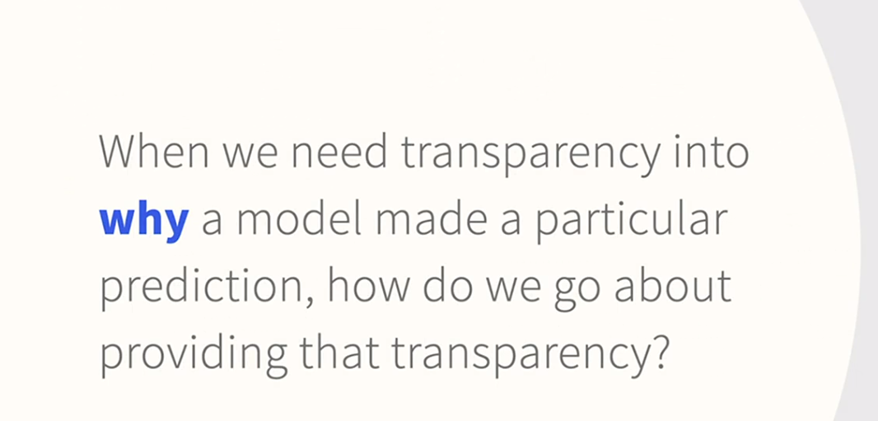

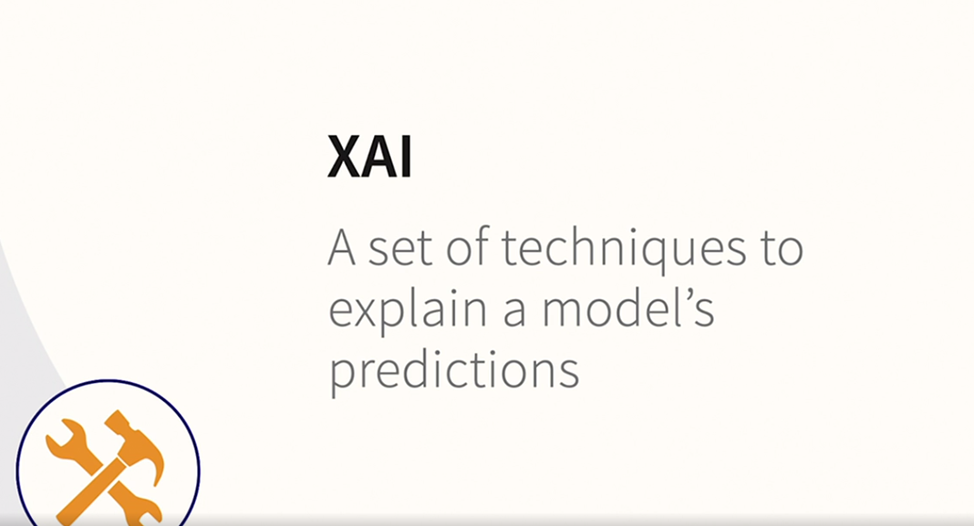

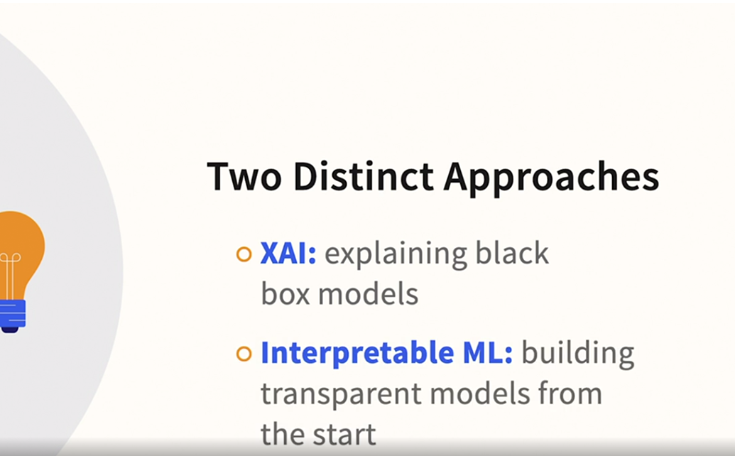

### **Variable importance and reason codes**

Selecting transcript lines in this section will navigate to timestamp in the video

- [Instructor] This course will have some hands on application, so let's take a closer look as to what these explanations might look like in practice. What are some of the practical applications of explainable AI that you might encounter? Have you ever applied for a credit line increase or a more favorable mortgage rate rate or premium credit card and have been declined? In the US and many other countries by law and explanation has to be sent out, and the letter lists the reason codes that may have applied in that situation. Let's assume that you're trying to refinance your mortgage to take advantage of a new lower and you shop around at multiple banks. If you aren't careful about how to go about it it might generate multiple inquiries on your credit report. So you get a decline letter from one of the banks and it gives a brief explanation with a reason code. Let's say it's the reason code 85. The explanation in the letter is too many inquiries. Well, you can scroll down here on reasoncode.org and there's a lengthier explanation than you likely were able to get in the letter that came**. As we'll see later in the course, this kind of explanation is called a local explanation because it's giving you information not about the predictive model overall but this very specific situation.** On a commercial financial planning website, nerd wallet.com, there's a credit simulator. N**ow I'm not logged in, and I don't happen to be a customer of this particular website, so it's giving generic advice. But you can see here that you can include specific information and get a more detailed analysis. This is what we will later refer to as a counter factual analysis.** So that gives you a very tangible sense of how XAI related techniques are being used behind the scenes, serving customers of these websites, even if the customers aren't aware of the technical context that is providing this information.

### **Comparing IML and XAI**

Selecting transcript lines in this section will navigate to timestamp in the video

- [Instructor] We've mentioned that there are two distinct worldviews and approaches to providing transparency in our model's predictions. Let's start by discussing the explainable AI approach in more detail**. Black box techniques, like deep learning and XG boost, are increasingly popular.** They dominate the list of winning entries on machine learning competitions, like those on Kaggle, but their very nature makes them difficult to explain or interpret. **For example, in medical AI, there are models that can accurately indicate the presence of disease, but it is often unclear, even to a doctor, how the model was able to make that determination.** Yet, there are situations, including medical AI**, where we need to be able to explain not only what the predictions are, but why that particular prediction was made.** This is also true of the loans and reason codes that we discussed in the previous video. So the motivation for XAI is that it addresses this increasingly common dilemma. **We want to use these opaque models for their accuracy, but when we do, we sacrifice transparency. XAI potentially tips the scales, and makes it easier to proceed with opaque models. Later in the course, we'll explore why black box techniques are trending and increasingly popular. And what about them makes them so difficult to interpret?** For now, let's stay focused on how XAI is a potential solution. What is it all about? Well, there are various kinds of XAI, but they all have something in common. They all involve an existing model that is not easily explained, and then performing some additional analyses to explain the model. Since these additional analyses are done after the model is built, they are often described as post hoc explanations. In this course, we'll explain various methods for doing this, and then we'll look at how to create these explanations in the KNIME analytics platform. XAI is not the only approach. Traditional machine warning techniques like decision trees are inherently explainable and interpretable. It is in the very nature of the technique that you can get a fairly detailed accounting of why particular predictions are made, although, you have to be careful to double check how various experts use the term. We'll use the term interpretable machine learning for building machine learning models that are interpretable, because the algorithm that was chosen results in a transparent model. I've also encountered this described as intrinsic interpretability, which really just means self-explanatory, but will stick **to the term interpretable machine learning. In addition to decision trees, techniques like linear regression and logistic regression, among others, fall into this category.** Some modelers worry that it implies that we have to fall back on techniques that haven't changed in decades. Frankly, that's okay, because sometimes the older techniques are just fine, but interpretable machine learning doesn't force you to use techniques that might seem out of date, or that fail to be cutting edge. Some researchers have recognized the importance of having inherently interpretable techniques, and they're working on powerful modern algorithms for doing so. Some of these researchers have adopted an almost contrarian point of view, voicing the opinion that we rush to black box models and XAI too quickly. So in this course, we'll acknowledge that black box models are an important part of machine learning, and we want to present you with options for both explainable AI, as well as interpretable machine learning.

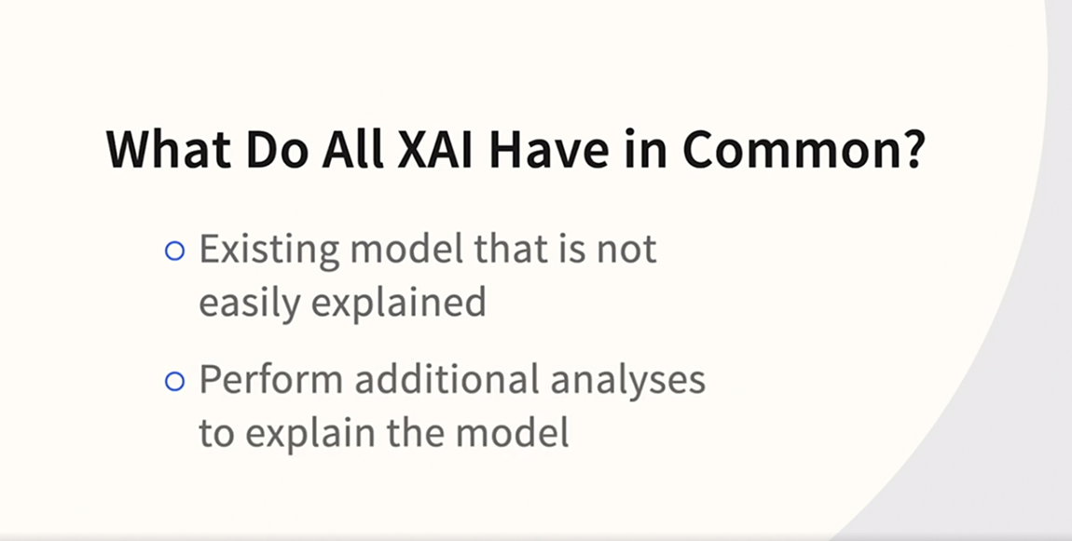

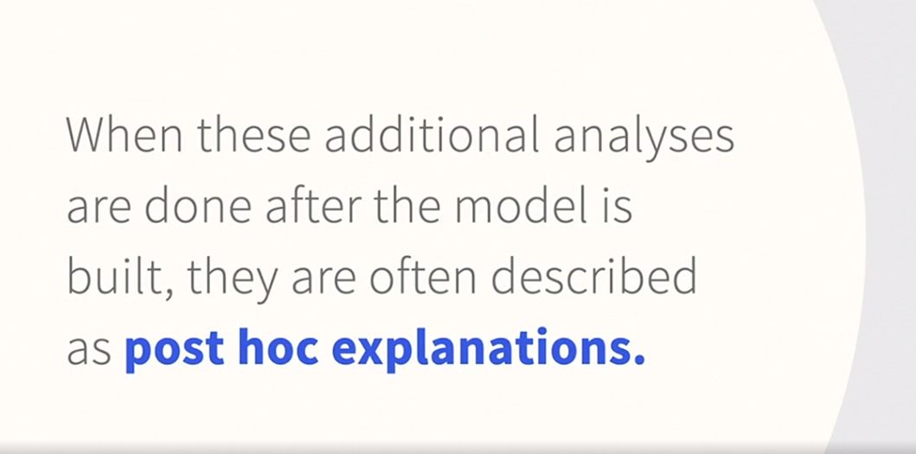

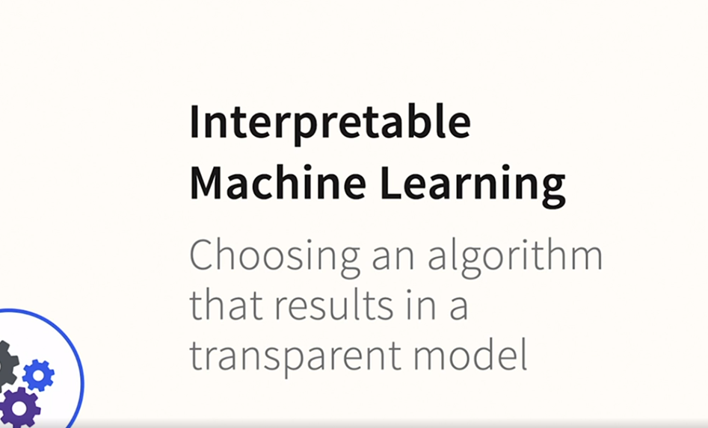

### **Trends in AI making the XAI problem more prominent**

Selecting transcript lines in this section will navigate to timestamp in the video

- [Instructor] I'm mid-career, but I've been using machine learning algorithms for about 25 years now, so I can start to look back with a bit of perspective. A lot of incredibly important machine learning innovations are much older than that, dating to the middle of the last century. So as data scientists, we're still using a lot of techniques that were already available when I was just starting out. But admittedly, computers were much more limited back then. As a result, we generally built single decision trees more often than we did ensembles. And if we built a neural net, we were taught that it should have just one, or at most two, hidden layers. What you might call a shallow neural net today. But we didn't call it that back then because all neural nets were shallow. Computers have been getting steadily faster and more powerful over the years, and that's a big factor. But if you're looking for that critical milestone, it would be 2012. That was the year that deep neural nets became famous. Researchers had been trying to get them to work for decades. But finally in 2012, all the factors came together, faster computers, bigger data sets, and deeper neural networks. In 2012, Geoffrey Hinton and his team won the ImageNet competition with deep learning. The competition had started in 2010 and continued until 2017, but 2012 was a very important year. Recently, ImageNet has moved over to Kaggle, and there's an ImageNet object localization challenge on the Kaggle website. ImageNet is not just a competition. It's a very large data set of labeled images. The annual competition involved building a computer vision model that could do object identification using the data set. In 2010 and 2011, the winning models were shallow neural nets. In 2012, along came Hinton's team, and they produced a dramatic, attention-getting drop in the error rate. They did so with eight hidden layers, which was considered an unusually large number of hidden layers at the time. That's why we call it deep learning. It's referring to the number of hidden layers. This was so influential that it sparked a revolution of sorts, and Hinton shared the prestigious Turing Award a few years later for a lifetime of contribution to deep learning, research that had finally paid off in a very visible way. And then the use of deep learning spread rapidly. What made 2012 such a major milestone is that soon these neural nets abandoned tradition and they had hundreds of hidden layers. And the error rate is now so low that it has plateaued and is now better than human accuracy. There are two additional elements that are present in the contemporary machine learning community that are putting additional pressure on those of us as data scientists to adopt black box techniques. One is AutoML, and another is Kaggle. Automated machine learning tools feature what one might call a tournament of algorithms where numerous algorithms compete and either a single winner is chosen or sometimes a team of multiple winners are used in a combined model. In other words, an ensemble. Kaggle competitions typically award a monetary prize, so some objective criteria needs to be used. And accuracy is calculated to multiple decimal places. These competitions have created a venue for a whole generation of data scientists to learn and to demonstrate their knowledge. So this is very positive overall, but it can create behaviors that are rather different than what you would see in the workplace. And it puts pressure on competitors to increase model complexity, even if it's only for very modest gains. Meanwhile, in the world of decision trees, a related transformation has been going on. Decision tree models have also been becoming increasingly complex. Single trees are rare complex enough to win these machine learning competitions. It's almost always ensembles of trees. Ensembles can be very powerful. Ensembles are a combination of any kind of model, but typically trees are the most common component model. I have an entire course dedicated to using this technique successfully, but the very large number of component models makes interpretation virtually impossible. In short, while the component trees may be transparent, the resulting ensemble is not. These parallel trends are making opaque models more common than ever. They absolutely dominate certain application areas, and they also dominate data science instruction. But there's a cost. We now have a large number of these opaque models, but our need for transparency has not gone away. So as opaque models are trending, it also results in the rise of importance of our subject, XAI.

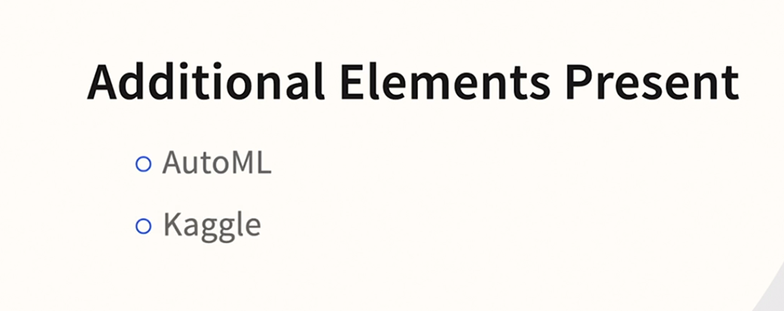



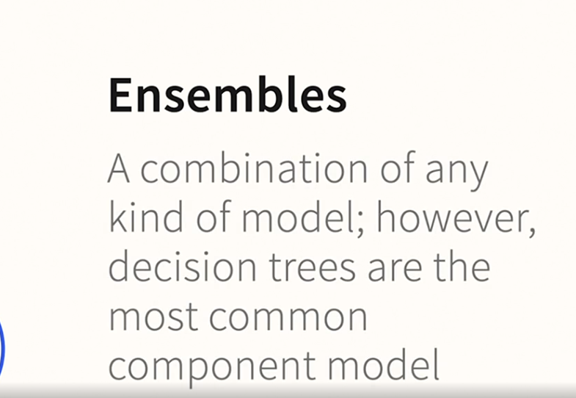

### **Local and global explanations**

Selecting transcript lines in this section will navigate to timestamp in the video

- [Instructor] We've seen that XAI, an interpretable language, are really quite different. It's also useful to subdivide XAI into two broad categories. We're going to use these two categories to organize the course. **Global explanations tell us what input variables are most important to the model as a whole.** If you are familiar with multiple linear regression, it's the standardized beta weight, which allows you to make an apples to apples comparison of the importance of two or more variables. Refer to the standardized beta, and you can say which variable was more important. Be careful though, if you are not familiar with the subtleties of an algorithm and choose the wrong type of indicator, this can prove to be more difficult than it seems. We'll explore these challenges later in the course. By extension, if you do have the proper type of coefficient, you would be able to rank a bunch of variables from most to least important. And that's a common task. We often want to rank our variables in this way. **Local explanations tell us which input variables were most important to make a specific individual prediction.** S**o now we aren't really comparing the inputs to each other.** Now we have a specific case, a specific insurance claim or a specific mortgage application or a credit card transaction. And we want to know why this one case got a particular prediction. In this way, it's exactly like the reason codes and credit card denial letters. So this is how we're going to proceed. Here's a high level overview of the structure of the entire course. We're going to finish getting a good theoretical foundation. Then we're going to get oriented to nine for our hands on practice. Then XAI with global explanations, then local explanations, and we'll end our course by giving advice on how to build the best possible, interpretable machine learning models.

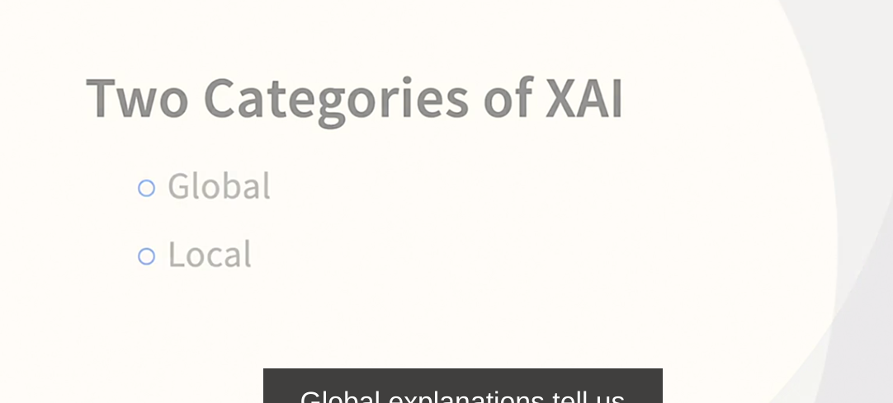

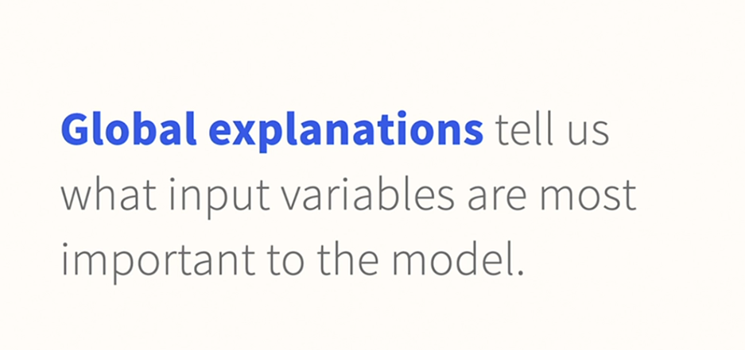

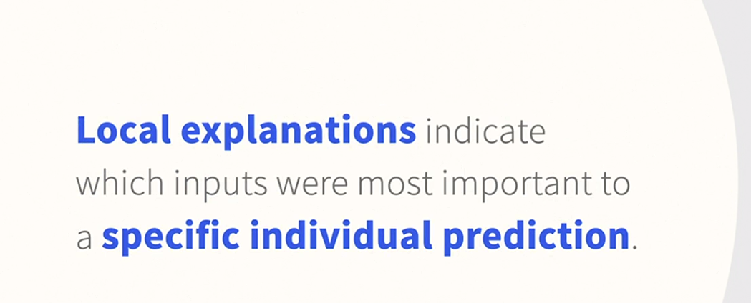

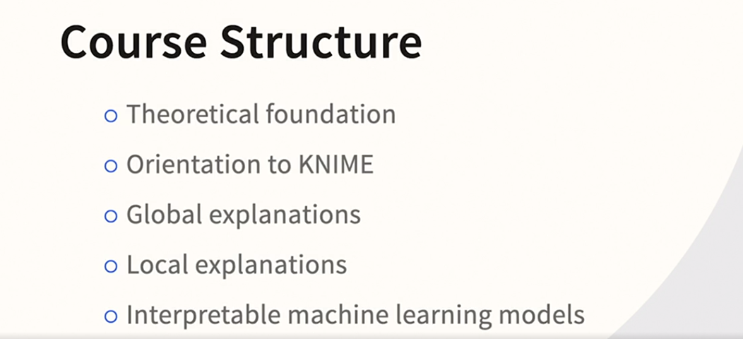

### **XAI for debugging models**

Selecting transcript lines in this section will navigate to timestamp in the video

- Imagine that you build your model, do cross validation and everything else you've been taught, and yet when you start to put the model into user testing the performance is awful. In a recent interview, Marco Ribeiro tells a compelling story. We'll be hearing more about that name because he's the lead author of the paper that introduced LIME, one of the techniques we'll be discussing. He explains that he didn't set out to study XAI at first. He became interested in it because he ran into a problem on a project. The model had learned to distinguish between how we had collected positive and negative data rather than picking up on what it should have been picking up on. The researcher and academic Cynthia Rudin, a name we hear repeatedly in this course, often refers to a similar case study. **A medical AI model was discovered to have been detecting the presence of a word in the image rather than diagnostic clue in the image itself. Both of these examples are a reminder that cross-validation alone is not sufficient to protect us if something about the data collection or data preparation impacts both our training data and our testing data. We need another layer of protection**. We need a way to detect if something like this might be happening. We also need to know how to improve our model with real-world human expertise, both of which are difficult if the model is opaque. If you are already actively building machine learning models you've likely heard stories like this, or have had experiences like this yourself. it is an important reminder that we also need explainability and interpretability for ourselves. This isn't just about meeting an external requirement. If we are to do our best work providing accurate, stable, useful, and helpful models, we need to understand them. Whether we choose to build interpretable models or explain opaque models, we need to take steps to understand our own work as thoroughly as possible.

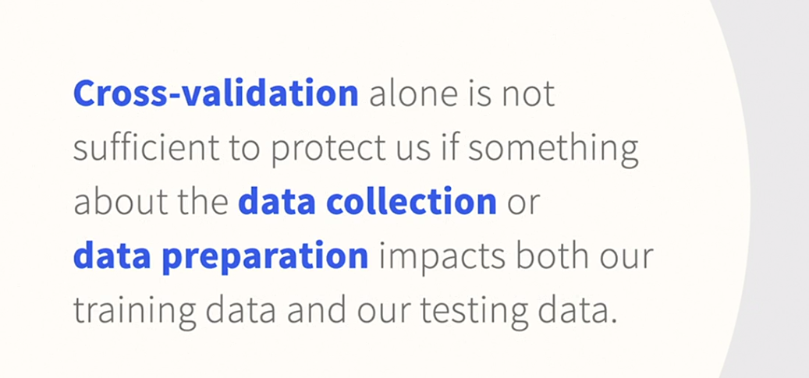

### **KNIME support of global and local explanations**

Selecting transcript lines in this section will navigate to timestamp in the video

- [Instructor] Since this course has a substantial hands on component I want to give you an idea of the kinds of reports we'll be generating in nine before we get a little deeper into the theory. Also, if you have any prior knowledge of XAI you may be curious if we will address any of the techniques that you may have encountered or read about. And naturally, you might want to get a preview of what this all looks like in nine. So on the global explanation side, nine supports three of the most commonl**y discussed techniques, partial dependence plots, global surrogates, and permutation feature importance.** But Nine is adding new techniques all the time. Let's take a look at a consolidated report that nine generates on the global side. This is what nine calls the global feature importance view. Now it's not the only way to get at global XAI in nine but it's a great way to give you a taste of what it all looks like. This generates multiple reports, what you're looking at now is the surrogate GLM model. And you can see on the right hand side color coded bars indicating the relative importance of a number of variables. **On the local explanation side nine also has very good coverage, both Shapley and SHAP values, LIME, counterfactuals, and ICE plots.** So again, let's take a quick peek as to what this looks like in nine. This is what nine **calls the local explanation view and it generates a variety of reports.** What nine calls the local feature importance is similar but not identical to LIME. And counterfactuals are a topic that we'll be discussing later on in the course. So I hope you're as impressed as I am with these consolidated reports. Although you're going to learn as we go along that nine is capable of reports like this as well as when needed individual XAI techniques, like all the ones that we've just listed. You can run them individually or in these consolidated reports.

## **Question 1 of 7**

The most important variable in the random forest credit card model is late payments. This is an example of _____.

* inherent explanations
* global explanations  
  Correct  
  It is global because it is the most important variable in the model overall.
* local explanations

## **Question 2 of 7**

Reason codes are examples of _____.

* inherent explanations  
  Incorrect
* global explanations  
  Incorrect  
  Global explanations attempt to explain the entire model. Reason codes are different.
* local explanations



Replay

Review this video

Local and global explanations

2m 23s

## **Question 3 of 7**

Which algorithm generally produces a model that is inherently interpretable?

* linear regression  
  Correct  
  Linear regression is a classic example of transparent model.
* random forests  
  Incorrect  
  Random forests are black box models because of the large number of component trees.
* deep learning

## **Question 4 of 7**

To achieve greater accuracy, many modelers are willing to increase model _____.

* transparency
* complexity  
  Correct  
  It is generally considered a tradeoff that to get accuracy you have to be willing to accept more complexity.
* simplicity

## **Question 5 of 7**

Which algorithm has helped generate the most excitement for XAI?

* deep learning  
  Correct  
  XAI has become more popular during the rise of deep learning.
* linear regression
* decision trees

## **Question 6 of 7**

What is an example of a global explanation option in KNIME?

* partial dependence plots  
  Correct
* Shapley values
* SHAP
* LIME

## **Question 7 of 7**

In the context of XAI, why is debugging models important?

* There might be an error (bug) in the model's code.
* There might be some incorrect data in the original training dataset.
* Models that seem effective during development sometimes fail during the evaluation phase.  
  Correct  
  XAI can tell you that the model appears to produce accurate results, but for the wrong reasons; it will fail on new data.

### **Challenges of variable attribution with linear regression**

Selecting transcript lines in this section will navigate to timestamp in the video

- [Instructor] When we talk about explainability and interpretability, it is often mentioned that if we could only get by with very simple models like linear regression and they were accurate enough, we'd be all set because they are inherently interpretable. This is partly true, but it takes a surprising amount of familiarity with the techniques to make this reverse engineering happen in practice. So starting with linear regression, we'll explore that even with the simplest of models, it's not always easy to articulate the relative importance of the input variables. We're going to be using a famous data set, the Auto Miles Per Gallon Data Set, which you can find the original on the UCI Machine Learning Repository which is a great source of practice data. However, I have a modified version of this data set that I'm going to be using for the demonstration and will be providing to you. Our version will have miles per gallon as the dependent variable and just two independent variables. Weight and tons and horsepower. It's truly as simple an example as we could consider. Naturally, we will anticipate that heavier cars will consume more fuel, and we will expect that the higher horsepower cars will also consume more fuel, but what will be the relative importance of these two variables? How easy or difficult will that be to determine when running a multiple regression analysis? In order to prepare this example, **I worked in the Excel analysis add-on, so we'll take a quick peek at the data and the results, but there's no need to click along for this one. We'll be focused on the concepts for now and I'll be providing the spreadsheet to you.** So here we are in the modified data set. First, the original dataset has weight in pounds but I've added a column that's weight in tons. I find that it just makes the interpretation easier. That's the only reason. There's no major theoretical point being made there. I did however, create an interaction term which is shown in Column D, Horsepower times Tons, and that will be an important part of the demonstration. Finally, if you do want to try this on your own later, what you're going to want to do is go to the data menus and the data analysis tool. Now this will only be there if you've installed it. It's an add-on, but that's all we're going to do. In two terms of point and click. There we go, looking back at the data and let's start looking at the results. So the first result that we're going to look at is the regression I got when I predicted miles per gallon with just tons. And I've zoomed in and I've highlighted on two things, the coefficients and the R squared. And we see that we got just about of 70% of variants explained. When we did horsepower all by itself, I got just about 61% of variance explain for the R squared. And then I also have the coefficients for that. Horsepower and tons are very different things, so the coefficients are, they actually look superficially similar because they both start with the digits one five, but their orders of are magnitude different. We're going to focus on tons though. So what we're interested in at the moment is how much tons changes when both tons and horsepower are in there together. So quick reminder, tons, negative 15. Now with both variables in there it's closer to negative 12, about 11 and a half. This is important because this is not a complex model, but the beta coefficient for tons is still altered with the presence of the other variable. What would cause that to happen? Well, let's briefly digress from the regression and pause to run something else. And I have a tab in here for that. I ran a correlation of the two, and it's extremely high. So as you would expect to get horsepower, you need a big engine. And if you've got a big engine that adds to the weight of the vehicle. There's no surprise there, but what's important is the impact that it's having. So when we add the interaction term, which is almost certainly going to be necessary here because they are highly correlated with each other, we now have the variable being predicted by horsepower, tons, as well as horsepower times tons. I'll go ahead and highlight all of those coefficients. And we can see that tons is sitting now at negative 21 and a half. And the interaction term, by the way if your regression fan is highly significant. So it seems like adding that term was necessary. Also notice that the R squared went up. Now, I've just thrown a lot of numbers at you. So let's review the numbers, just focused on R squared and tons and see if we can figure out what conclusion to draw. So let's first talk R squared. When we put it all together, we can see the following pattern. Tons explains more, but horsepower explains almost as much. Yet, we can use them together and the combination is only slightly more than tons alone. Look at that. 69.3% of variants explained for tons alone and less than a full point more when we use both together. Again, there's overlap there, major overlap in this case. But when we create the interaction term and add it, there's a noteworthy jump from 70.6 to 74.8. There's a lot to be said for how to tease out these relationships. And much of that is covered at some length in my regression course. Not appropriate to go into that deeply now. The point is that they both contribute. Tons seems to contribute more, but dividing their contribution fairly is not obvious, even for such a simple model. Now let's talk coefficients. A quick reminder of how the beta coefficient fits into the regression formula. It's how much miles per gallon goes down for each additional ton of weight. By the way, if you think in metric terms a ton is about 900 kilograms. So let's review how the coefficient changed a bit in these different modeling scenarios. The first model we looked at was tons all by itself in the model. And that relationship was a reduction of 15.3 miles per gallon per additional ton. When we added horsepower into the mix, the beta weight per tons, note we're still talking about the beta weight for tons but in a different modeling scenario, the drop was lower per additional ton, 11.6. Presumably because some of that adjustment to MPG was being explained by horsepower. However, now all of a sudden, when we have horsepower and the interaction term, it's dropping 21.5. Now keep in mind the Y intercept is changing along the way. The coefficient for horsepower, when it's present is changing along the way. All of these things are in flux. The point is, if you run just one model, it's the most accurate model. If you think it's the model that you to go with, you might not be attending to these changes. And I'm hoping that this will draw more attention to this phenomenon. So what do we conclude? Well, when we report something that has such great interest to our colleagues, clients, and management, like variables are most important, it's a fundamental thing that everybody wants to know, we have to tread carefully. Even with the simplest models, we should examine more than one model and consider more than one method of measuring variable importance. In short, it's not a bad idea. To use some of the explainability techniques even when we're using a transparent model, like multiple linear regression.

### **Challenges of variable attribution with neural networks**

Selecting transcript lines in this section will navigate to timestamp in the video

- [Instructor] The typical explanation of neural nets is that they get so large and complicated that they become impossible to explain. Let's explore a very simple and shallow neural net and discuss how easy or difficult it is to explain. Let's imagine that this time we're building a neural net to predict miles per gallon using horsepower and the weight of the car in tons. So we have two input variables, one target variable, and three nodes in the so-called hidden layer. But what about an interaction term? We don't need one because the hidden layer mimics the behavior of an interaction term. The hidden layer's job is to address variable interactions and curvilinearity. So how would we determine the importance of the input variable, tons? We just need to know the magnitude of the relationship between tons and miles per gallon, right? Well, we already have at least two major problems, and this is just about the simplest neural network one can imagine. These days, deep neural networks have many orders of magnitude, more nodes, and parameters than shown here. Nonetheless, we still have some complications to talk about. Here's the first problem. Tons has three parameters flowing to the hidden layer. The three will differ in magnitude and possibly even direction. So there is no one answer to the question, what is the relationship between tons and miles per gallon? Here's the second problem. We know from the linear regression and common sense that tons has a negative relationship with miles per gallon. Heavy cars need more fuel, thus lower fuel efficiency. But, is that accomplished with the first parameter being positive and the second being negative? Or is it the reverse, the first being negative and the second being positive? Or could it be both? Not only is it possible, it's very likely. Remember, we could have hundreds or thousands or even billions of these parameters. Microsoft recently made an announcement about a neural network with trillions of parameters. In fact, there could be a complex interaction that causes some of these paths to have a positive relationship. Not unlike what you see in a complex polynomial that curves and twists up and down. Where does this leave us? The good news is, we don't have to create interaction terms. We also don't need to add polynomials to address curvilinearity as we do in regression. And we don't have to worry about feature engineering. In theory, all of that is addressed for us. The bad news is, the changes in the topography or shape of the neural network will have a big impact, so we might not get a good network on the first try. And as this very simplistic example indicates, we've lost almost all transparency into the relationships. So we need to address that in some way, which, of course, is the fundamental topic of this course, XAI.

### **Rashomon effect**

Selecting transcript lines in this section will navigate to timestamp in the video

- [Instructor] So you've built your model and you're listing your input variables in order of importance. You're excited to share this information with the team. And then you wonder, you almost went with a different model. You tried lots of different models. And the one that was second in terms of accuracy was nearly as good a performer. What if you had gone with the other model? Would this list of the most important variables be similar or perhaps rather different? The name Rashmon comes originally from a famous mid-century Japanese movie by Akira Kurosawa. In the film, four different witnesses describe a murder, **but with differing and often contradictory details. It's become a metaphor for different points of view. The use of Rashmon as a metaphor in machine learning comes from a very influential paper by Leo Breiman.** "The Two Cultures". Leo **Breiman was a brilliant innovator that along with others brought us techniques like CART and Random Forest. He writes, "different models, all of them equally good, may give different pictures of the relation between the predictor and response variables." "The question of which one most accurately reflects the data is difficult to resolve." C ynthia Rudin of Duke University and her colleagues have taken this one step further and introduced the idea of a Rashmon set, which they define in this way, "The set of prediction models that provide near-optimal accuracy." In other words, there's more than one, so collectively, they form a set that together are all near the top in terms of performance.** Why is this important? Well, it seems to undermine our ability to figure out what's important, which is such a fundamental question that we need to ask. **"Existing variable importance measures do not generally account for the fact that many prediction models may fit the data almost equally well."** Rudin and her co-authors continue, "In such cases, the model used by one analyst may rely on entirely different covariate information than the model used by another analyst." Wow, so you think you figured out variable importance, but if you had chosen a different model, the list might have been entirely different. In the paper, they even propose an algorithmic approach to address this called model class reliance, but short of implementing their algorithm, there is some general advice that we can explore right now. First, awareness helps. Now that you've heard about this problem, you'll start to perceive it more readily. Where you really get in trouble is when you're highly confident that you figured it all out and then you're contradicted later. Awareness will make you more cautious and less likely to do that. Second, run variable importance on more than one model. Be extremely careful about picking a single most accurate model running variable importance on it, assuming that it's a stable and accurate list and immediately writing a key driver analysis to management. If the list is unstable, and you give different advice later, it will be confusing to everyone. Frankly, including yourself. If the top three performing models are very similar, then you're on more solid ground. Next, perform good variable reduction. The reason is is that this Rashmon phenomenon tends to be more pronounced and produce more instability when you have lots of very similar inputs competing with each other for the same variants. You want to remove some of that redundancy and I find that this helps. Finally, always include a transparent model in the mix. If all of the models that you've tried are black box, you've got less context. Even if the transparent model is less accurate, at least you've got some options to compare. So the Rashmon effect is very real, now that you're aware of it, you'll perceive it, but there some things you can do.

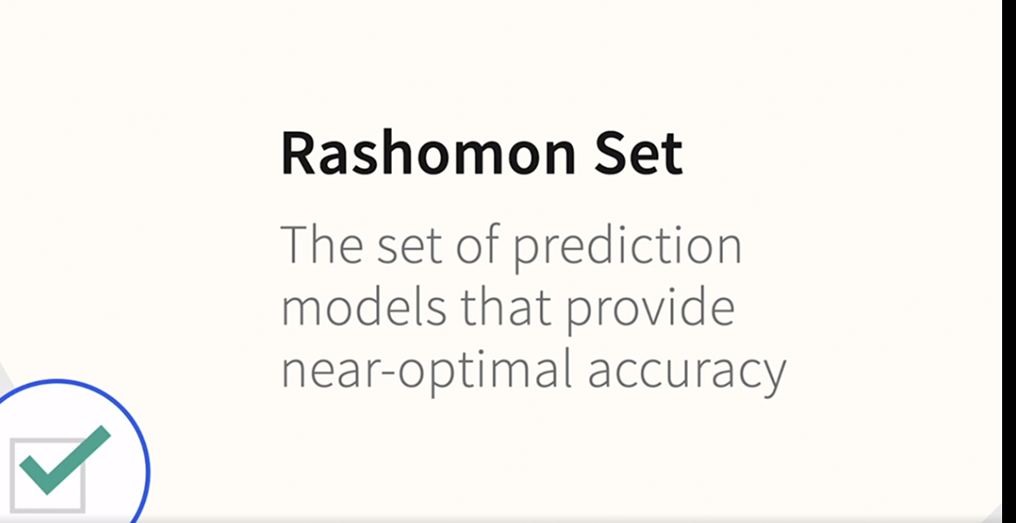

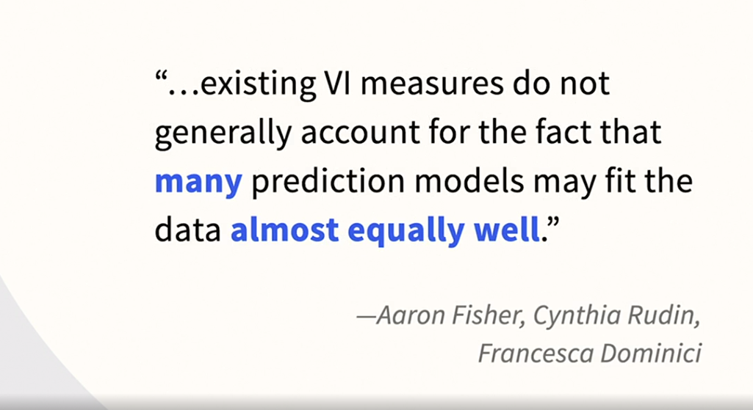

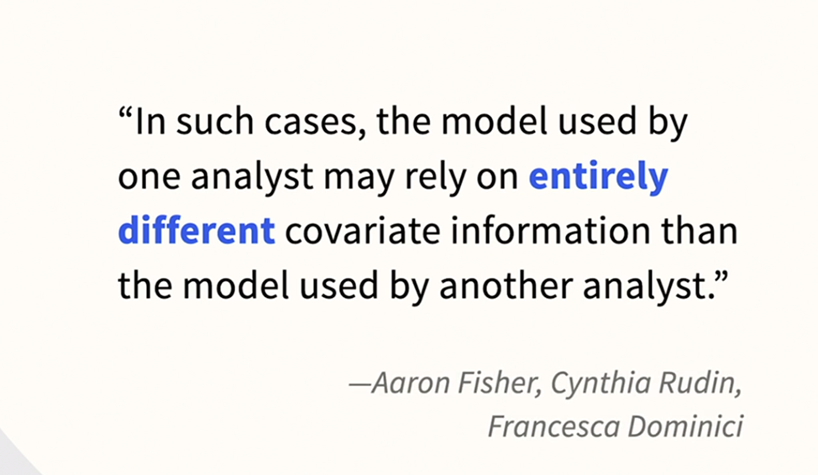

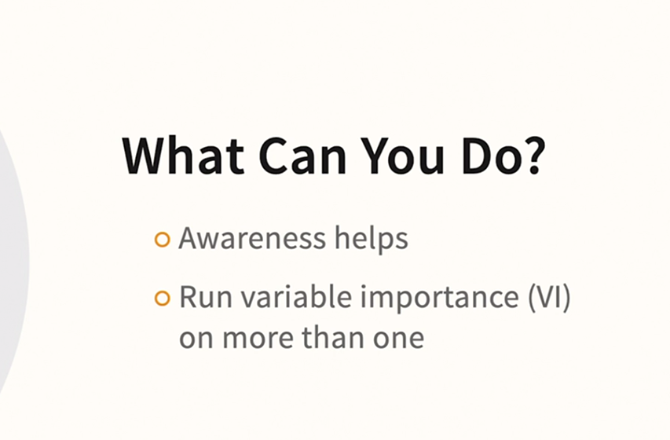

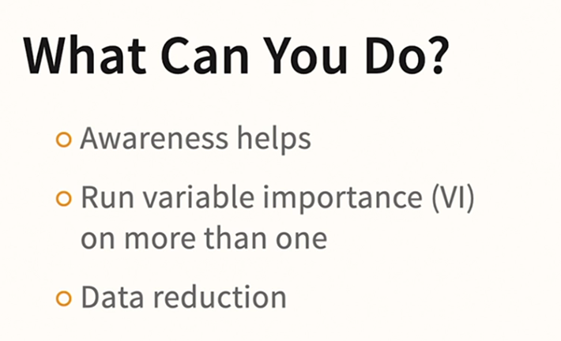

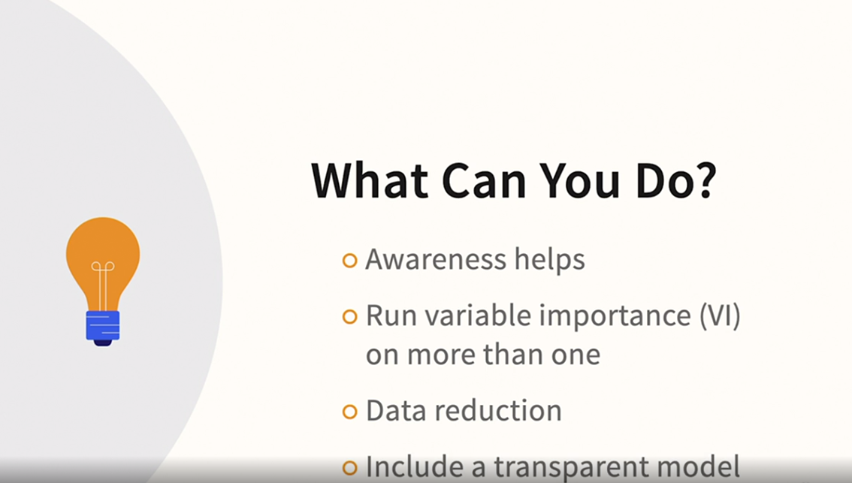

### **What qualifies as a black box?**

Selecting transcript lines in this section will navigate to timestamp in the video

- [Instructor] In an article in ProPublica, the authors explored racial disparities and sentencing between White and Black defendants. I won't explore all the subtleties of the controversy, nor summarize both sides of the argument, just one specific issue that's especially relevant to our discussion. What model should be treated as black box models? In a Harvard data science review article, Cynthia Rudin and her co-authors attempted to reverse engineer the compass risk score. The compass risk score is used to predict the risk that a released prisoner will commit again in the future. And it was the score that was discussed in the ProPublica article. In response, members of the team behind the compass risk score wrote setting the record straight, explaining that they didn't use a black box technique. They used logistic regression. In a further response, Rudin wrote that it doesn't matter if the model was logistic if the score is proprietary and kept secret. Obviously, hearing both sides of the debate could fuel an excellent case study in AI ethics. And I encourage you to read the entire series of articles at the Harvard Data Science Review, but for our purposes, it raises an interesting question. When, as a practical matter, is a model a black box? In other words, when might you need the XAI techniques in this course? The classic definition, of course, is a model so complex that it's impossible to interpret, because of the nature of the algorithm that was used. Traditional machine warning algorithms are usually considered as automatically belonging in the transparent model category. But when you put this in a broader context, it might be safer to consider three categories as black box. First, of course, are those complex models deriving from black box algorithms, but also models with large numbers of inputs. If a decision tree has several levels and dozens of leaf nodes, it starts to become a real challenge. And that should probably be considered a black box model as well. Finally, as we've just seen, if a model is proprietary, and you're not allowed reveal the model details in their entirety, you likely still need something, like the reason codes that we explored earlier in the course. So in all three of these situations, you may find that providing transparency becomes a challenge, and therefore, in all three situations, you might want to consider some of the techniques that we will be seeing in this course.

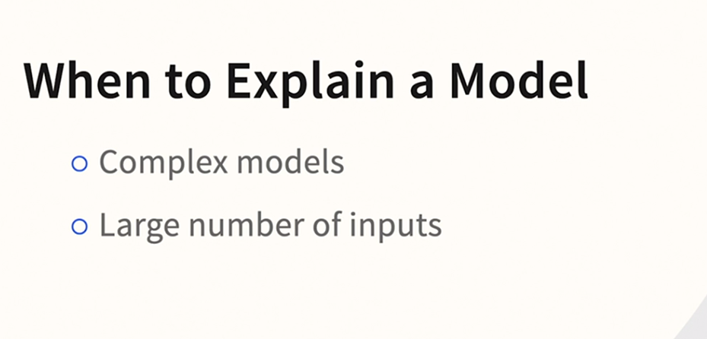

### **Why do we have black box models?**

Selecting transcript lines in this section will navigate to timestamp in the video

- [Instructor] So if complex black box models have the potential to create challenges and extra work, there have to be some compelling reasons to do it. I'm going to list what I believe to be the most important reasons influencing the contemporary data science community. Each of these could be debated. And remember you always have choices. By the time the course concludes, you'll have a lot of information to weigh into your own decision to pursue either interpretable machine learning or black box with AI. Here are some of the main arguments I encounter in the data science community in favor of black box. The first reason that comes to mind, of course, is accuracy. The basic premise is that complex models are always more accurate. The full story is a bit more subtle, but this reason is so important that we'll dig a bit deeper on this one in the next video. I think we're also influenced by famous case studies natural language processing has demonstrated in our smart home devices. And technologies like autonomous vehicles would be impossible without the advances in deep learning. So there's an assumption that it's also the best choice in all industries. We won't explore in this course if this assumption always holds, but there's no question that the use of deep learning is increasingly widespread. Another reason is convenience. Traditional machine learning is hard, particularly feature engineering. Data prep is famously the majority of the work in a traditional machine learning project. Black box techniques are perceived as reducing, or even eliminating, some of this work. I think another reason is philosophical. Way back in the '80s, a popular approach to AI was expert systems in which the computer scientist would interview an expert, like a lawyer or a doctor, and hardwire that subject matter expertise in the form of hand-coded rules. In a series of debates with cognitive scientist Gary Marcus, Turing Award winners Yoshua Bengio and Yann LeCun have discussed this. Marcus argues that we need some hardwiring because babies and animals seem to have it. Bengio and LeCun argue that we want to discover as much as possible from the data without hardwiring. In one debate entitled "Does AI Need More Innate Machinery?" LeCun who, keep in mind, is a true giant in the field, answered the answer is probably yes, but not nearly as much as Gary thinks. How does this seemingly abstract debate affect our discussion? Even something like feature engineering can be seen as this kind of hardwiring. Now a debate like this will never completely resolve itself. It's a bit like nature versus nurture. But the black box techniques like deep learning are seen as a way of reducing this hardwiring. Any innate machinery, to use that phrase, is seen as moving backwards, back to the way AI was done in the past. I encourage you to check out this debate in its entirety. Finally, there's a growing generation gap in data science. Mid-career data scientists invariably learned traditional machine learning first. A newer generation of data scientists may have, in some cases, learned deep learning first or possibly even learned it exclusively. That may even describe some of you. There's a natural tendency to turn first to what you know best. However, for strategic reasons, I urge you to always consider a transparent model first so that you have a baseline established. We'll return to this advice when we discuss interpretable machine learning in more depth. You may have additional or different reasons for favoring black box for certain projects, but those are the reasons I encounter most often. I encourage you to discuss the pros and cons with your colleagues and uncover some of the reasons they have and some of their success stories with black box models.

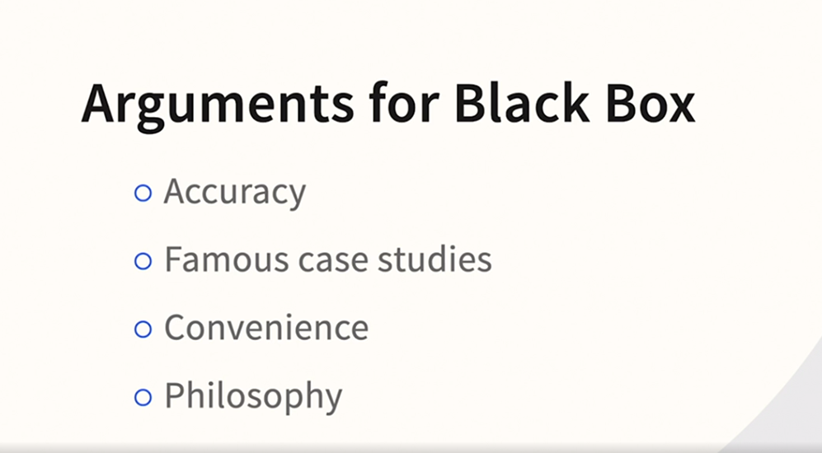

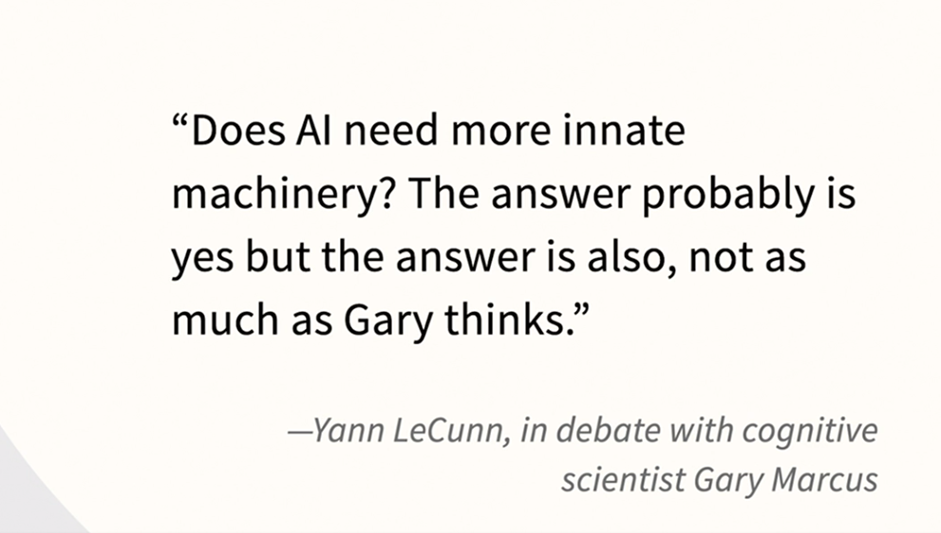

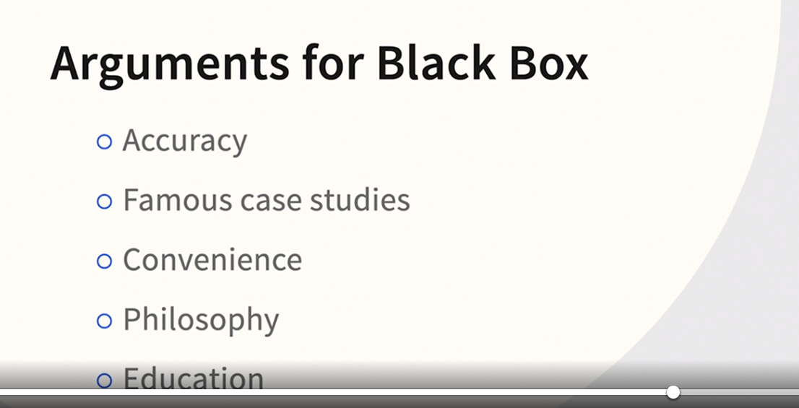

### **What is the accuracy interpretability tradeoff?**

Selecting transcript lines in this section will navigate to timestamp in the video

- [Instructor] So what exactly is this accuracy interpretability trade-off? Well, on the internet, you'll find dozens and dozens of charts like this one, but it's not always clear exactly what is being measured on the x and y-axis. It's mostly just being asserted to be true. One fact of agreement to everyone, and it certainly is true, is that linear regression belongs in the upper left corner and deep learning belongs in the lower right. However, it's rarely clear in blog posts or in videos you may find whether the author did some kind of experiment or if they're attempting to generalize. However, if you want a serious discussion of this, and it definitely is a real phenomenon, **it's hard to improve upon the extremely influential book "Introduction to Statistical Learning" by two giants of the field, Hastie and Tibshirani, and their coauthors. Hastie has a website supporting the book that you see here, and he also makes the book available as a download.** The relevant figure for us is figure 2.7. And you can see that they've labeled this a little bit differently. They've labeled the x-axis flexibility and the y-axis interpretability, and in the chapter in which you find this figure, they talk at length about what is called the bias variance trade-off. I invest multiple videos in this whole concept and discuss it in detail in my Introduction to Classification course. And Hastie and Tibshirani in the book make a much more careful argument than what you might find in those charts on the web that I just referenced. So the basics are almost universally agreed upon, so let's talk about those now. So rather than generalizing, we can be more specific. A couple of facts are absolutely true, and there's no debate. A polynomial regression is always more flexible, as Hastie and Tibshirani define it, than a linear regression. If you're looking at a scatterplot, it is quite literally true. The polynomial regression can bend, demonstrating its flexibility. So r squared will always go up. That's just a fact. A complex tree is more flexible than a sparse tree, meaning if you grow a decision tree an additional branch, accuracy is going to go up, and flexibility's going to go up. That is also without debate. So therefore, what Hastie and Tibshirani are trying to show in that figure, figure 2.7, is that more complex is associated with more flexible, as they define it and as I've begun to describe to you. However, this is where it becomes a little bit more subtle, and there's a little room for debate. Is flexible always better? If you're simply talking about interpretability and accuracy, I think most people immediately draw the conclusion, "Wow, I want more accurate. I'll deal with interpretability later." But, again, the argument is more subtle. Is flexible always better? Well, right in the book, Hastie and Tibshirani talk about circumstances where you might sacrifice flexibility for interpretability, really the theme of a big section of this course when we're going to talk about interpretable machine learning. But the other issue is it's one thing to show that you always get increased accuracy on training data. And when you start to talk about evaluation and when you start to talk about user testing and applying these models in the real world, it's not always true that flexible is always better. So remember this trade-off because you're not forced to go black box and then explain it. You'll have to on an individual, project-by-project basis try to navigate the trade-off between these different choices.

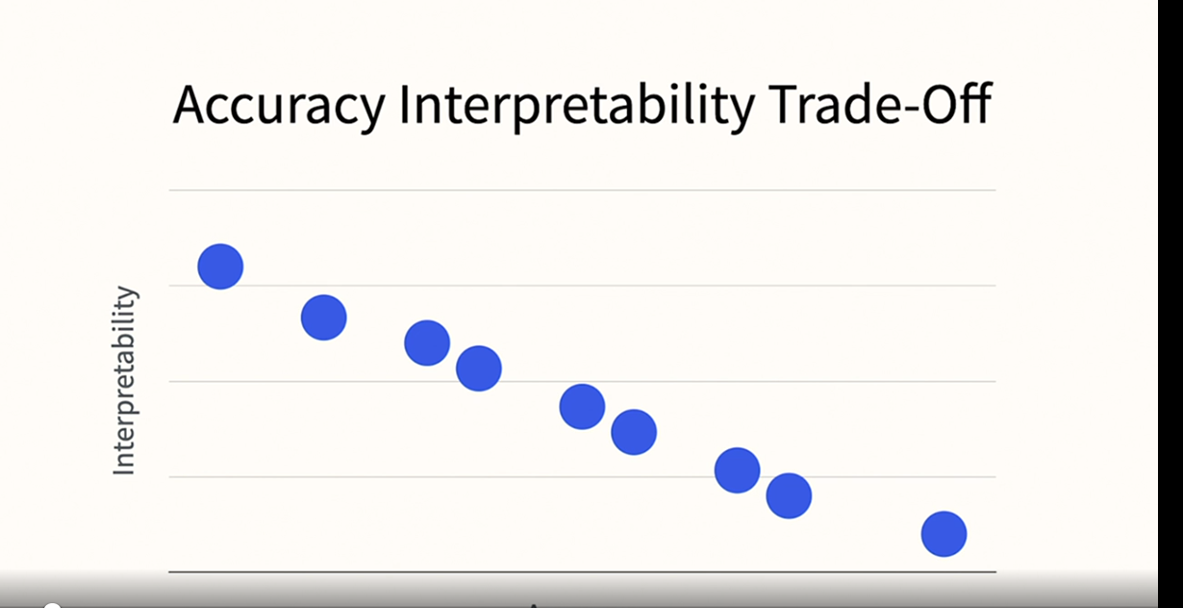

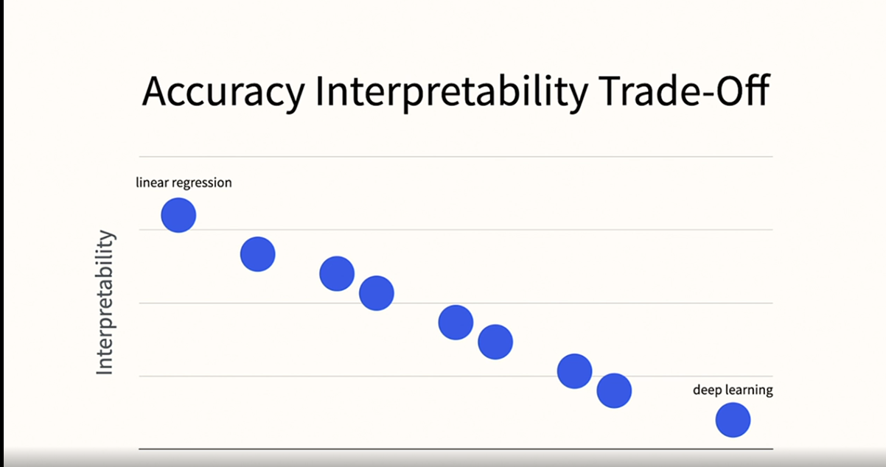

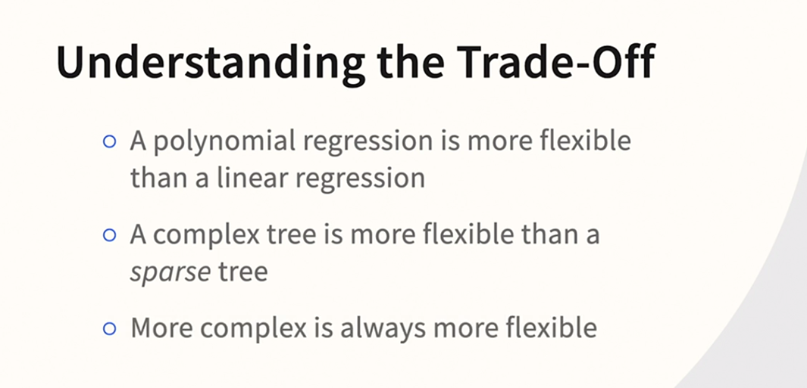

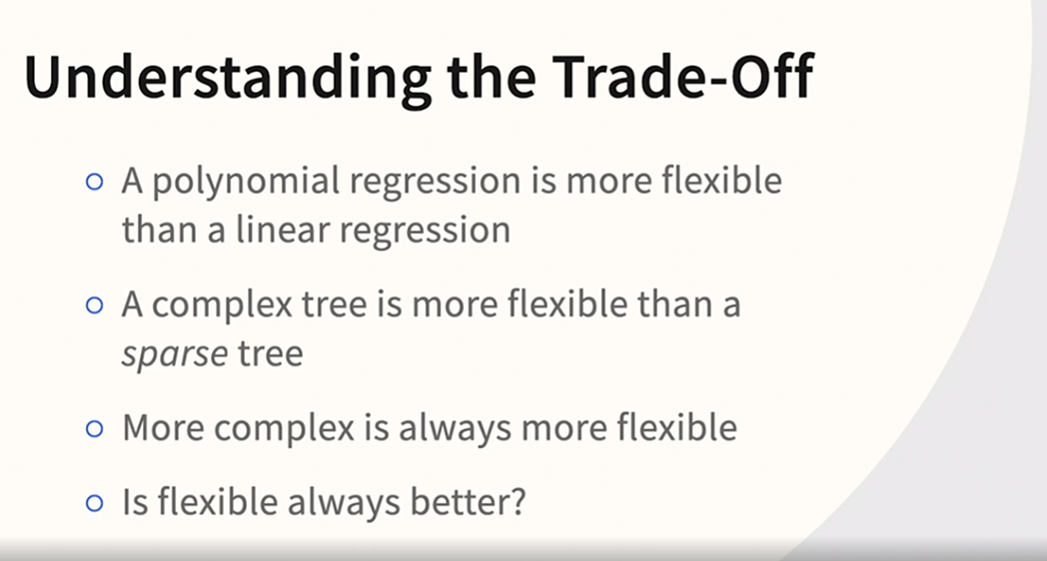

### **The argument against XAI**

Selecting transcript lines in this section will navigate to timestamp in the video

- [Instructor] The first time I encountered the ideas of Cynthia Rudin, I was attending her keynote at the 2019 Knowledge Discovery in Databases conference in Anchorage, Alaska. The premise of her keynote was perhaps we're using complicated models when we don't need them. You can find her keynote on the internet, and I highly recommend it. She's become very vocal, and she's taken a strong contrarian position on explainable AI, but she's very well regarded. She recently won a million-dollar award for pioneering work in socially responsible AI. I'd like to briefly summarize the key points of her position. If you're curious to learn more, she's prolific, so it's easy to find articles and presentations where she discusses these points in more detail. She and her graduate students have also made a number of technical contributions to the field, some of which we'll see later in the course. First, she argues that accuracy is rarely a good argument for building a more complex model. She believes that the accuracy complexity argument is exaggerated, or perhaps even false. Her reasoning is that even if theory tells us that complex models are better, when you actually do this work in practice, opaque models are rarely substantially better. This is something that I've seen in my own work, so you want to be careful and thoughtful when making the choice to build an opaque model. She also argues that black box models can be harmful. They can be wrong, and then no one knows, and if you don't understand them, you also can't use subject matter expertise to make them better. Next, and perhaps here she's being even a bit more controversial, she argues that opaque models are easier to keep proprietary, therefore, there is perhaps a financial interest in either using black box models, or keeping transparent models secret. Finally, she passionately argues that the field should be more focused on advancing interpretable machine learning, where she's made some advances herself, and not being so focused on XAI. Her position, in summary, is to consider using interpretable machine learning from the start, and then you don't need explanation. We're taking the position in this course that black box techniques in interpretable machine learning are going to coexist for the foreseeable future. So explaining black box models is better than not explaining them, but it's helpful to be reminded that we almost always have a choice. We'll have more to say about interpretable machine learning later in the course.

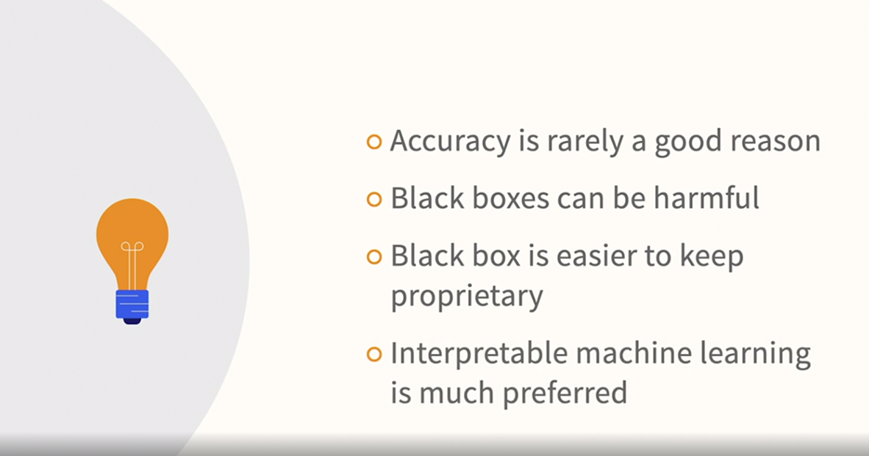

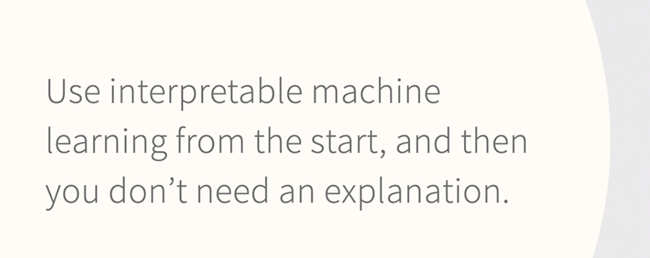

### **Introducing KNIME**

Selecting transcript lines in this section will navigate to timestamp in the video

- [Instructor] Okay, I want to take a couple of moments to orient you to the KNIME Analytics Platform. It's open source, it's easy to install, it's easy to use, and it has great support for explainable AI. So it's perfect for our purposes. Also, both the KNIME Staff and the KNIME Community, are very supportive. Lots of resources ranging from online forums to webinars, and an excellent YouTube channel, KNIME TV. I also have an introductory course right here in the library. I'm not going to get into installation because KNIME has excellent support for that. All you have to do is go to the download page and follow their instructions for your operating system. If you're an existing KNIME user, make sure to download the latest version, because some XAI features are quite recent. Also, you want to download the KNIME Extensions and you can find them here. I've had very good work with the extensions over the years, not only the official KNIME ones but also the Community based ones. Okay, let's take a moment to do the quick tour, although I'll keep this brief. In this course we're going to stay focused just on the XAI related features. But, for now let's get oriented. So one of my favorite tricks is the EXAMPLES. And if you go to the EXAMPLES Server here and do as it says, double click to see the EXAMPLES, it will take a moment, but there's just a ton of them. So for instance, if we go to analytics and statistics we can see Performing a Linear Discriminant Analysis for instance, something that we won't be doing again in this course, but I want to show you how the EXAMPLES work. And I also want to show you this. You might want to close some of these other windows to give give yourself more room, and zoom in so that you can see that better. Let me quickly orient you to the basic feel of KNIME. If you right click, you can execute these one at a time, and the traffic light coding is as follows. Red means that something has to be indicated inside the node for it to run, yellow means that it's ready to run, and green means that it has run. So again, we're not focused on Linear Discriminant at the moment, I just wanted you to see a KNIME workflow. So, what if you're looking for something related to Decision Trees? We can start to type decision in here, and we actually can see a number of the nodes that would be related, including the Spark Decision Tree Learner, and normally help would come up but we had closed some of those windows so that we could zoom in. I want to show you another one of my favorite tricks. If we go up to view, we can reset perspective, tell it that indeed that's what you want to do, and those other windows come back. That way you can close these other windows or zoom in, zoom out without being afraid that you won't know how to bring those various things back. So there you have it, we're going to be spending some time in KNIME and you will get oriented as we go. But if you download it, make sure that you have those extensions, explore the EXAMPLES Server. For the purpose of this course, you have everything that you need to know.

### **Building models in KNIME**

Selecting transcript lines in this section will navigate to timestamp in the video

- [Narrator] Okay. We're in a newly restarted copy of nine. You don't need any data files. You don't need any workflows. We're just going to do very simple review of how to build a model in nine, and we're going to do so with existing resources right within nine. So first, let's go to the example server and log in, and then we can go to analytics. And here we go. I want this one actually, classification and prediction modeling. And the very first one will be just fine for us, example for learning a decision tree. So double click on that. We can zoom in a little bit. I think we have room to go even one click higher. I'm not going to try to reproduce the amount of detail that you would see in an introductory nine-course just enough. So that you'll be familiar with the look and feel of a modeling workflow. So we've got the data coming in, by the way it's some information about the shuttle and we can right click on that and execute. And the yellow indicator will go to green. And now that it's executed, we can read the table and maximize that. I just wanted to show you that the data came in. We're not going to worry really a lot about the nature of the data set or what's being predicted here. I just wanted you to see that the data did successfully get rid in. So I'll close that, then we're partitioning into train and test, and I won't edit that at all. I'll just execute it. By the way, if I were to execute on the far right hand side, it would all run and would all turn green. It's really only for illustration purposes that I'm doing this one step at a time. You'll frequently see the color manager, let's go in and take a look. That's something that's going to appear in quite a few workflows in this course, it's simply a way to control the colors that get assigned to your fraud, non fraud, or your purchase non purchase, or what have you. That's all it is. So it's not going to have an important theoretical role but you will see it in a number of workflows in the course. And then of course we have our decision tree learner. Let's take a look at that. Our target variable is found in column nine, that's indicated here. You may wonder why there's not more choices showing up. It's because that's the only string variable. So one of the things that can be tricky about nine when you're not used to it, is whether the variable is an integer or a string or a decimal and so on, can prevent it from being included in certain menus. So when you are certain that you read the variable and successfully, but you don't see it in the menus, that's one of the first things that you want to check. So let's go here and execute and open views. And there you have it. We're not focused on scoring at the moment, but we certainly do want to look at our results and here they are. So what's a little bit unusual about this dataset is we're predicting a lot of classes. If you happen to be curious about the dataset it happens to be a dataset from the UCI data repository. So you certainly can take this workflow and experiment with it and go deeper into your under standing of nine. But what we need to know at the moment is that we successfully built our model and that we're in the decision tree. And when we see a plus, we can expand that and look in more details at the tree. In fact, we could expand again, and then we actually get to the point where we would have to scroll to see them all. We'll have time to spend more time looking at the tree diagram at this point, we're really just rehearsing the mechanics. So I'll go ahead and close that window. Then finally, if you want to know some of the options that are available here, we can go into configure for the score. And one of the things that that's going to do is give us the results. You know how successful our model was. We can execute and open views. And I know that's going to be pretty small on the screen since we're not focused on interpretation in this video. I won't tempt to zoom in on that, but it's a confusion matrix. It's telling you when the model said class three, was it really a class three? When the model said class zero or class four, was the model accurate about that? So it's our confusion matrix. We won't be focused very much on the confusion matrix in this course, we will be focused on the tree diagram and we'll certainly have to understand workflows but there you have it. That's just enough to be comfortable with the demonstrations that we're going to be doing that involve modeling and workflows and nine.

### **Understanding looping in KNIME**

Selecting transcript lines in this section will navigate to timestamp in the video

- [Instructor] Okay, we're picking up where we left off and we're going to do a very brief introduction to looping in KNIME. So why looping in KNIME for a course about explainable AI? Well, as you get deeper into the features that KNIME offers for XAI, you may on occasion encounter features that require looping. And that's because a lot of these techniques iterate through the data, multiple permutations or multiple samples. So if you spend a lot of time doing XAI in KNIME you may encounter some of these nodes that have this looping structure. So let's go into the example server. And we go down to control structures and there's many kinds of loops but I want to keep it simple because again you're not really going to be writing loops. What you may encounter is loops that are already in workflows that you're downloading. That's why you need the orientation. So we can do the simplest possible loop there is. So let's just do example 10 here, looping a fixed number. Double clicking on that, and it's loading. We've got room to zoom in a little bit here. We have just enough room for that and you can see the, it it's just four nodes. So this is probably intuitive once you're looking at it. But what the very simple observation to make is that you want to identify the loop start and the loop end and everything in between the loop start and the loop end is going to be repeated. So we could have a dozen nodes between loop start and loop end, and they're all being looped. So looping, isn't something within a node. It's all of the nodes in between loop start and loop end. So let's take a very quick look at this data set. It's just a very basic counting loop. You can see there's a very unusual dataset. It's just got one row here because what the loop is actually going to do is append things. So if we go in and we take a look at the loop inside it's going to do a thousand loops. So some things happening a thousand times, I wonder what that could be, well this node is appending something, oh wow, we're appending something a thousand times. I think you can anticipate where this is going to go. I'm going to execute the whole thing and go down to the collected results. And now we have a whole bunch of rows. We started with just one row, but now we have a whole bunch. Obviously not a detailed example but that will be sufficient to prevent you from being disoriented if you encounter an XAI related workflow that has a loop.

### **Where to find available KNIME support for XAI**

Selecting transcript lines in this section will navigate to timestamp in the video

- [Instructor] So, where do you look in KNIME for XAI related resources? Well, remember that KNIME is community based. So sometimes you have to be a bit creative. You will sometimes have to look at the hub. So there's basically three places to look. **First, the example server is always a great resource**. So you'll discover actually if you go to examples, analytics, there's an entire section for machine learning interpretability and then within that you have currently five workflows that you can draw upon, although certainly there'll be more added over time. And then down in the node repository normally you would, you know just search for **nodes that have been in KNIME for a very long time. You can generally, for instance, decision trees.** Everything is just there. But when things are being added all the time you want to search a little bit more thoroughly than that. **So always keep a lookout for things that might be appearing in the KNIME labs**. And we actually, if you go to KNIME labs, you can see that we actually have an interpretability section there. **And we've got support for LIME, for SHAP and for Shapley.** Note, the looping structure that is present for all three of those, you need a loop start as well as a loop **end. Now, if you go up here to the hub and you want to search for XAI it's going to take you to a browser. So let's just take a look at the hub website**. So from the browser, you can search XAI and you can see there are ton of resources here currently showing 76, again certainly with more coming over time. So we see not only a description but supporting workflows for things like the XAI view, for instance. Further down we see the local explanation view. Numerous support blogs are included in here as well. For instance, if we go to XAI view, not only do you have an opportunity to download the component, for some of these you'll download the workflow, you get substantial documentation right here. So you want to consider all three of those possibilities. The examples server, the node description, and particularly the KNIME labs and the KNIME hub.

### **Providing global explanations with partial dependence plots**

Selecting transcript lines in this section will navigate to timestamp in the video

- [Narrator] We are about to explore global explanation techniques. And we're going to start with Partial Dependence Plots which graph the effect of a feature on the outcome. Here, we've zoomed in on one variable and a credit example that we'll be using throughout our discussion of global and local explanations. The Y axis is risk and the X axis is times in debt for one to two months. How long someone is late and how often they are late are strongly related to credit risk. But after a value of four on X axis the relationship seems to plateau. Let's go into KNIME and do this example step by step. First, I want to just direct you to some information about this data set. The data set is called, Give Me Some Credit and it's found on the Kaggle website. It's also referenced on the KNIME website and I'll have more to say about that later for now I'm going to suggest for at least this first video and global explanations that you just watch get oriented and then you can find the necessary workflows and data sets and try it on your own. Okay, here we are in KNIME. This is a workflow which will be provided in the course resources named after the chapter 05 01 XAI PDP. There is a similar workflow available in the KNIME resources. You can actually, we find it on the example server. And if you scroll down to analytics and then scroll down to machine learning interpretability there actually is a sample workflow on Partial Dependence Plots. I have modified it so that we'll use the same data set credit score throughout. So you're looking at the modified version and we read in the scoring data. Then we partition. Then we're using XG boost which clearly is an example of a black box technique. There's also a necessary pre-processing step. Let's go in here for just a moment. What I'm doing is I'm taking just a fraction of the variables, some of the stronger relationships there. And if you want to know a little bit more about this node you can request the help for this node. It's a necessary step, but from a theory standpoint it's not the most important step. So let's go right to the Partial Dependence Plot itself. I'm going to click on cancel. Here again the variables that I've chosen are credit worthiness worthy and risky, and three variables from the set of variables to make this run a bit faster. It's times in debt for one to two months times in debt for three months or more times in debt for two to three months. Now let's execute this. So I'm going to choose the interactive view maximize. Okay, great. So we can see our Partial Dependence Plot and our X axis is times in debt for one to two months. And our Y axis is risky. So what we see is that we have a risk between 0.05 and point 0.10 on the Y axis at no times in debt, but that rapidly climbs and as it approaches around four or five, it then plateaus. So we're getting a very visual look at the relationship between this predictor and risky credit behavior. Let's go on up to the upper right hand corner the settings button, and here I can choose from my list of features and the prediction. Now, remember I've only sent it a subset of the predictions but I'm not going to go to three months or more. Give it a moment. And we see a modified picture, don't we? Because of course the X and Y axis haven't changed but the graphic has changed. Now we also see that rapid escalation pattern but it starts to plateau more like three. And the amount of risk is substantially higher because this is now times in debt for three months or more 90 days, not that smaller amount. So there you have it. That is a Partial Dependence Plot. And once you look at your features one at a time against your target variable.

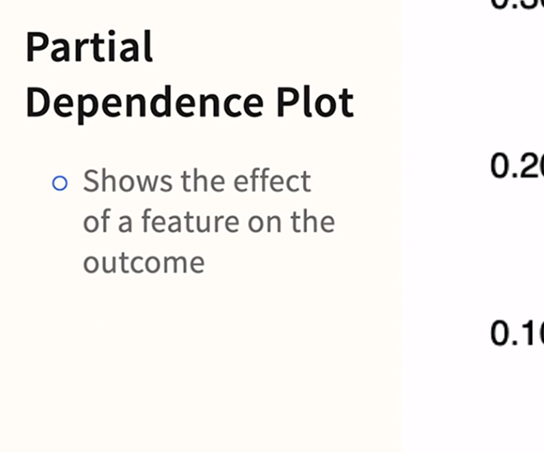

### **Using surrogate models for global explanations**

Selecting transcript lines in this section will navigate to timestamp in the video

- [Instructor] A surrogate model is simply a substitute. When you feel that your project is best served by a black box model, you can build a second model that explains the first. Here's the key difference. Your target variable changes. Your new target variable is the output of the first model. In his excellent book, "Interpretable Machine Learning: A Guide for Making Black Box Models Explainable," which I highly recommend by the way, Christoff Molnar outlines the generic steps in more detail than I will here. We will do the bare minimum at first. A bit later, we'll learn that KNIME can help us with surrogate models. **So the first step is to get the predictions from the black box model, then train an interpretable model on the predictions, meaning that the predictions of first model become the dependent variable of the second model, then measure how well it replicates.** When we do the demonstration in KNIME, we're going to skip this step to keep it simple. By the way, it is okay if the surrogate model is a bit over fit, because the nature of the model is quite different. A lot of the noise has been worked out of the system with the first model. It's quite common that the accuracy on the second model is quite high and a bit over fit. Finally, you have to interpret the model, which we'll practice in the demonstration. So let's proceed into KNIME and see how this all works.

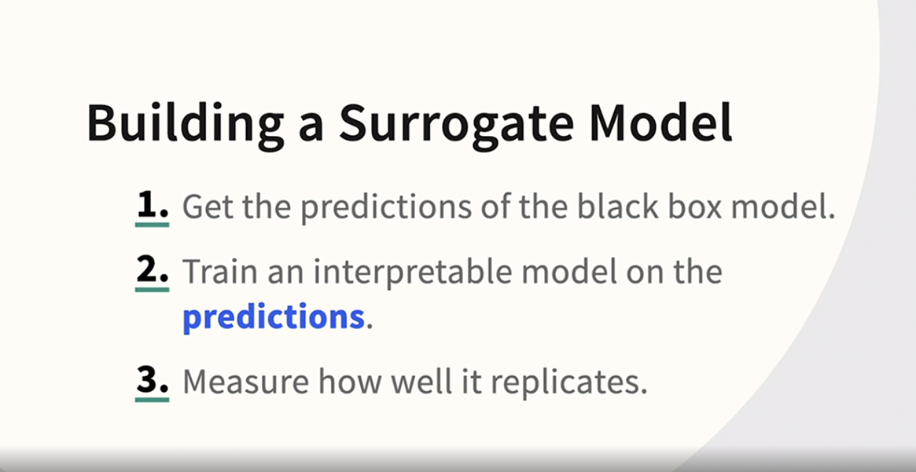

### **Developing and interpreting a surrogate model with KNIME**

Selecting transcript lines in this section will navigate to timestamp in the video

- [Instructor] Let's build a surrogate model in nine. So in this demonstration, we're going to do the bare minimum to get a feel for what it's like to build a surrogate model. And there's an important step that we're not going to take in this case, because we're actually going to learn that there's a very easy shortcut and not for building a surrogate. But I want us to rehearse the basics, so we're in a workflow that's going to be provided to you, it's named after the video we're continuing to use the credit score data. We're balancing the data because there's an uneven amount of credit worthy and risky cases we're using XG Boost. And then here's the key step, the key step is adding the new regression tree ladder which I've labeled as the surrogate. So let's go one node prior, right Click and take a look at the predicted data at this step. So this is going to be a bunch of tiny numbers but we really only have to review the shape of the data at this point. So we have our target variable way over here, and we have our scrolling across the top here, we can see our features and then three new variables have been added because this is at the end of the process of building the model. So we have the predicted value of the target and adjacent to it just a little bit to the left we have the two scores. One of these scores is the riskiness score and the other one is its sibling, so to speak the credit worthiness score. So we're back to the workflow now. And what we're going to do is we're going to build a regression tree, but our target is going to be the information that we were just looking at. So we're going to use as our target information that was not available way over here at the CSV reader, but only available now that the model is built and being scored. So let's take a closer look at what I mean. If we go into configure, we can see that all of the features have been included, our target column creditworthiness, the a risky score and what has been excluded is the other score creditworthiness, creditworthy, and then the original target variable and the prediction. So we're using the risky score and all of the features to build our new model. The original target has been excluded. Didn't make any changes and let's execute an open use. And what we can see is that our overall risk in this balanced data set is a third. We see at the top, in the root node, we see 0.3301 so that's our overall risk. We split initially on debt to limit ratio and the sweet spot on that variable seems to be 39. So when that ratio was larger than 0.3941 it branches into the more risky category. In fact, on the left we have a risk of about 20%, on the right we have a risk of almost 60%. Let's see what else it branches on. Times in debt for one to two months on both sides and then look at those risk levels really a alternating I'm going to read from left to right here, we have about 16.8% risk, then it goes way up to 48%. If they have had time and debt greater than one half. Greater than one half of course doesn't mean a fraction, greater than one half means either zero to the left or one, two, three or more on the right. Then risk is still a bit elevated on the right hand side because you've got that high debt to limit ratio. So over here in this node, we have a risk of 49, over here we have a risk of 80, and if we further branch and it's starting to get more complicated now, if we add all these branches we continue to split on variables like time and debt for three months and time in debt for one to two months. So as we're about to see nine has an easier way to do this, but I wanted to do a partial demonstration of a manual surrogate model so that you could really understand the concept.

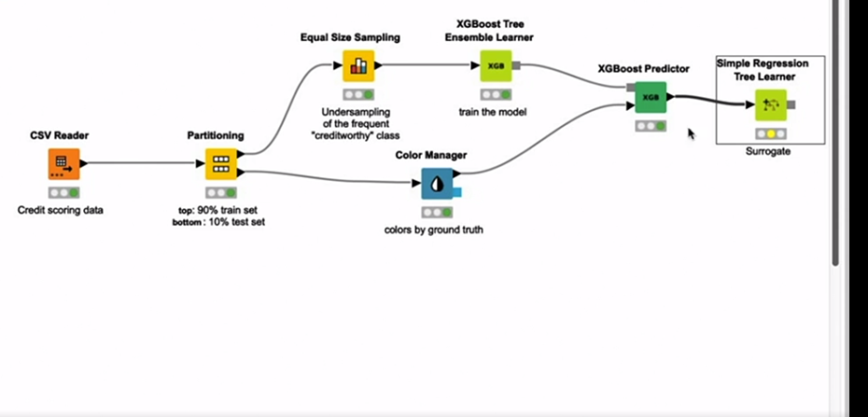

### **Permutation feature importance**

Selecting transcript lines in this section will navigate to timestamp in the video

- [Instructor] Now let's talk about permutation feature importance. The basic idea is straightforward enough but the method might surprise you at first. To test the importance of a feature we're going to shuffle that one column. What the shuffling does is break the relationship that is present between the feature and the target variable. That's the permutation in the name. So if the variable was helpful, the error rate will go up in a measurable way. And if the variable's not so helpful the error rate is not going to change. Once again we have Bryman and Rudin to thank once more for various contributions and Molnar is a great source on this topic as well. Now let's see how it works but we won't need a dedicated node in nine because nine includes permutation feature importance and its fantastic new resource, the global feature importance node.

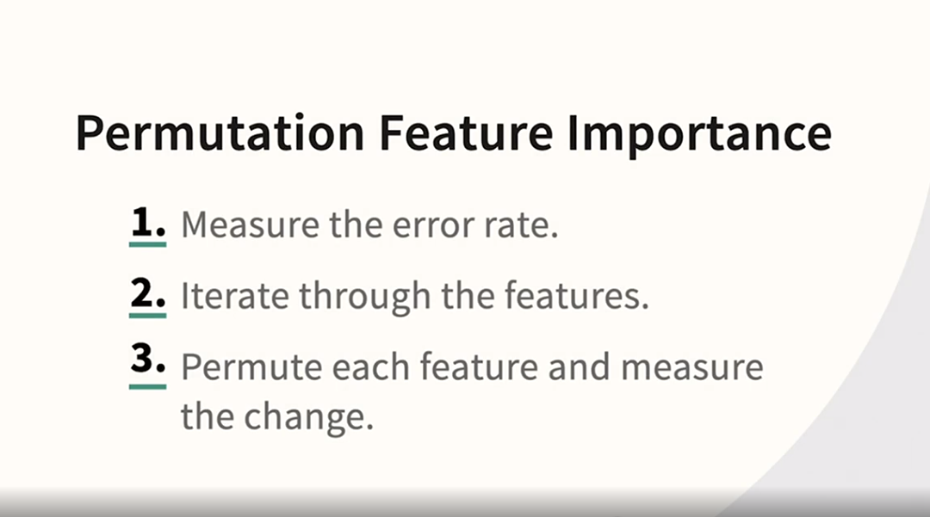

### **Global feature importance demo**

Selecting transcript lines in this section will navigate to timestamp in the video

- [Instructor] Okay, we're going to talk about the impressive global feature importance node in KNIME. I've tried to present the conceptual material so that you can apply it in any venue, frankly, not just KNIME. But what we're about to discuss is highly specific to KNIME, 'cause frankly, it's a kind of shortcut that's going to run multiple analyses very easily for you. So let me walk you through where to find it and how to use it. I think you are going to find it very helpful. So this component is able to compute global feature importance with up to four different techniques. So in one step, you're going to get multiple views at global importance. So you can find this description of the node on the KNIME hub, but even better than that, there's a completely worked up example, including a workflow. So you can find this also on the KNIME hub, and it's a complete workflow. And if you go to download, you can download the relevant workflow, and now we're going to switch over to KNIME and talk about it. So here we are, the data source is the credit scoring data, the same credit scoring data that we used for the PDP plots and for the surrogate. There's partitioning, as usual. Here's a step I just want to draw your attention to. We are doing balancing to improve the performance of the model. And this time, we're using the auto ML node. But the star of the show at the moment is this new node, the global feature importance node. So let's right click and Configure. Take a look at the options. Okay, so we're excluding creditworthiness from the features because, of course, that's our dependent variable. And I have made one change to the defaults. I have changed the performance metric from the default of F-measure to accuracy because I thought that might be a bit more intuitive, but that's the only reason. You absolutely could stick with the default or choose one of the others if you like. All of the features have been included. I have not added or removed them. They're the same as the workflow you would download, and they're all of the features in the data set. And if you look at the importance methods, you can see that there are four check boxes. I have neither added nor subtracted from those. We're going to do them all. Nothing was changed, and that's what that warning is telling us. So now we're going to go into the interactive view. And I think they've done a great job here because not only do they have a thorough analysis, there's a pretty good commentary, as well. So the first surrogate model is a surrogate generalized linear model. And notice that my request was accuracy, and it says that the accuracy is 96.6%. Now, remember, if you had an accuracy like that on an original model, you probably would be concerned that it might be overfit. We expect this kind of surrogate model to be overfit because we're fitting to the first model, not fitting to the real world. There's less noise. It's just a very different kind of fit. So that should neither be surprising nor concerning. It's actually a good number. It means that the surrogate model is giving us a good view into our first model. And if you take a look over here on the right-hand side, you can see that the top variable is times in debt for three months or more, times in debt for two to three months, times in debt for one to two months, consistent with what we've seen elsewhere. Scrolling down now, we have a surrogate decision tree, and there's a little mouse maneuver you can actually make here. If you hold your mouse over the tree, you can enlarge it, which I think actually looks pretty nice on the screen there. And you can see that the branches of the tree confirm what we just saw branching on times in debt for one to two months, then on the left, times in debt for three months, on the right, age, actually, as a sub branch. And then we see times in debt for two to three months, monthly income, times in debt for one to two months. And as you probably know from seeing this in other windows, those symbols allow you to further branch, so really pretty interesting and pretty thorough. And it couldn't be easier. Scrolling down now, we have a surrogate random forest, and the top variables are times in debt one to two months, three months. This consistency is really great. It makes us less concerned with those Rashomon effect phenomena. This is why it's helpful to do more than one of the original models, frankly, as well as more than one surrogate model. That's one of the things that's great about this new node is that it will encourage you, I hope, to run at least these three, and the consistency across is good. That means that we're not suffering the Rashomon effect perhaps as strongly as we might otherwise. If the list is very unstable, we start to get nervous about telling stakeholders about what that list is. And then finally, we have something that's not a surrogate model, but something different, what we've just seen, the permutation feature importance. So it's automatically doing the permutation, and then it's calculating that delta. Remember the delta is how much did the error rate change when that variable was shuffled, essentially taken out of the model. It's not physically removed, but by shuffling it, you don't get the impact of that variable, so you can see what happens when it's absent. The phrasing they use here is breaking the relationship between the feature and the target, again, consistent with that shuffling step that we've discussed. So here we go, what does this one reveal? Times in debt for one to two months, times in debt for three months or more, two to three months, and then the fourth variable is other real estate loans. So again, great consistency between this and other analyses, great consistency within the four analyses in this report.

## **Question 1 of 5**

How does permutation feature importance measure the impact of a variable?

* by changing its weight
* by "shuffling" the variable  
  Correct  
  The "permutation" in its name refers to shuffling the variable randomly to remove any relationship with the target.
* by removing the variable

## **Question 2 of 5**

What is the target variable of a surrogate model (for classification)?

* the propensity score of the black box model  
  Correct
* the top input variable of the black box model
* the target variable of the black box model  
  Incorrect

## **Question 3 of 5**

How many different surrogate models are presented in the Global Feature Importance node?

* 5  
  Incorrect
* 3  
  Correct
* 10  
  Incorrect
* 1

## **Question 4 of 5**

Which algorithm is a good candidate for building a surrogate model?

* deep learning
* decision tree  
  Correct
* random forest
* XGBoost

## **Question 5 of 5**

Which variables are shown in a partial dependence plot?

* all the variables
* only the target variable
* one input feature at a time against the target variable  
  Correct
* only the top predictors

### **General advice for better IML**

Selecting transcript lines in this section will navigate to timestamp in the video

- [Instructor] A premise of this course has been that complex black box models are here to stay, but interpretable models are also here to stay. Working directly with interpretable models can often be your best choice, but mastering interpretable models draws upon all the modeling skills that you develop over a career. Nonetheless, there are some general principles we can discuss at this point in our journey that seem especially suited to this course. Where I see folks get into trouble is that they sometimes skip data assessment and data prep and jump immediately to their favorite black box algorithm without trying anything else first. That strategy makes it nearly impossible to know if you're on the right or wrong track and if you've successfully avoided perennial problems like data quality issues or overfitting. Always try interpretable models first so that you can learn from your data and from your initial attempts. Then you also know the accuracy score that you need to beat and whether sacrificing interpretability is worth it. Also, it's impossible to do more traditional methods well without feature engineering. This can get a bit tricky because you may end up with multiple datasets. That happens because each of the traditional algorithms that you use might need slightly different data prep. Some techniques need this attention more than others, but without feature engineering, you aren't giving the interpretable models a fair shot. We'll have more to say about this in the next video. My experience and that of many of my colleagues has been consistent over the years. Transparent models often perform nearly as well as opaque models. But here's the difference between what I suggest and what I observe most rookies do, however. Don't simply give up after just one try and rush to deploy the top performer. If an opaque model was the best performer, treat it as a pace car. Go back to feature engineering and try to close the gap between the interpretable model and the opaque one. You may be surprised how effective this can be. Then even if you and your team decide that interpretable is the best option for you, that doesn't mean that you can't leverage the power of black box algorithms. You could build a 500-tree random forest model and compare its top predictors to the ones you found in a single decision tree. Are they the same or similar? That should give you greater confidence that you're on the right track. Are they completely different? That's indicative of the Rashomon effect. You should go back to exploration and data prep, specifically data reduction, and see if you can't introduce more stability into the solution. If you want to truly understand the performance and stability of your various choices, perturb the data and try again on a different training partition. Not only will you tend to find that performance is close across all techniques, you will also often find that the winner might change from one training partition to the next. That's also indicative of the Rashomon effect. It should make you more reluctant, I hope, to run something like AutoML just once and immediately deploy the first winner you find. Interpretability or even all of the XAI techniques we've learned isn't going to help you if the patterns that you're reporting up to management were true only in that one training partition but failed to generalize to new data. With so many options, far many more than can fit into this one course, there really is no excuse anymore to deploy an opaque model without either XAI or interpretability. So as you navigate your options, you're choosing from interpretable or opaque with XAI. Explanations in some form are now the requirement. Analytics management will eventually be learning about these techniques as well, but even if they don't explicitly require them yet, due diligence now requires one of these two choices.



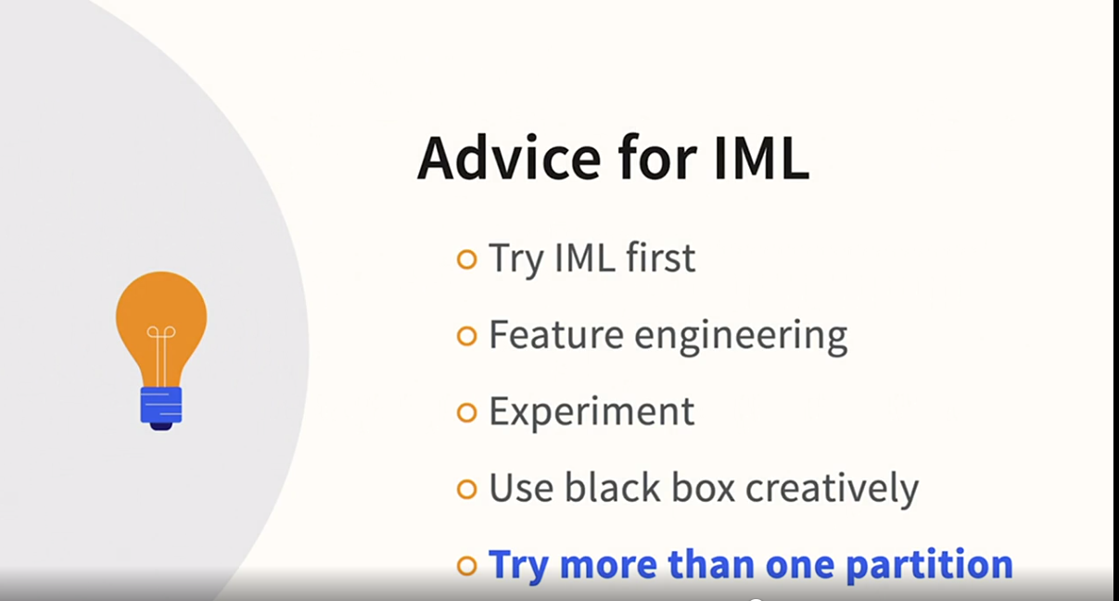

### **Why feature engineering is critical for IML**

Selecting transcript lines in this section will navigate to timestamp in the video

- [Instructor] Feature engineering is so important that even though you'll find it discussed in more detail in other courses, I want to try to illustrate its importance with a story. Years ago, I was working with a client on a binary logistic regression model. He was exploring pediatric root canals. Until that project, I didn't know very much about them, nor did I know how common they were. He had researched them in detail. Routine dental checkups were sufficient to prevent the problem, so which children were not getting their routine checkups? It had something to do with neighborhood and location. He discovered that families that had two working adults and only one family car had trouble getting to those appointments, but this could be mitigated by access to public transportation. So why not just put location information like zip code into the model, and let the algorithm figure it out on its own? Hmm. I wish that were true. If you put zip code in, then maybe, just maybe, you would get a little bit of signal in your model, but what you really have to do is give the model a helping hand. A complicated solution would be bus lines or something like that, but a simpler and quite practical solution would be to look up density population in zip code, like this information on the CDC website. If we scroll down, we get this very cool map, and it defines the zip codes into large central metro, large fringe metro, medium metro, and so on. And I'm certain that that ad information would be correlated with something like public transportation access. And this is readily available, and could be easily incorporated into the model. That's just one thought experiment, but please don't underestimate the importance of feature engineering and other kinds of data prep if you are building a true additional machine learning model. It's among the most important factors of all.

### **CORELS and recent trends**

Selecting transcript lines in this section will navigate to timestamp in the video

- [Instructor] I want to proceed with a very brief demonstration, but this demonstration will be a bit different because it won't be in KNIME. And the reason that we're not going to do this in **KNIME is because the CORELS algorithm, which stands for Certifiably Optimal Rule Lists, is not available in KNIME currently. So what is CORELS all about? Well, Cynthia Rudin and her team of graduate students and fellow researchers have been very active trying to modernize contemporary interpretable machine learning. So why do we need contemporary alternatives to excellent algorithms like binary, logistic, and CART? Well, decades ago, we simply didn't have the computer power that we have now.** So one of the problems with an algorithm like CART is it's a so-called greedy algorithm. Its performance very much depends on that first branch. If it doesn't choose an optimal first branch, it can run into trouble. And this is the kind of issue that CORELS and algorithms like it is trying to address. Let's take a closer look. If we go to the CORELS website, we can see there's a number of information here. So very briefly, what's a rule list? Many folks are more familiar with decision trees than rule lists, but they're closely related. They both generate rules in the form of if/then statements, but the nature of those rules is a bit different. So CORELS generates a rule list and you can run it. If you go to install, you can actually see that the information for GitHub is here. So you absolutely could run it in KNIME, we're just not going to get into the details of how to insert Python code into KNIME at the moment because there's also another cool option. We can actually run it online. And now, you may recognize why this is an interesting algorithm, and an interesting data set to demonstrate because this is actually the COMPAS dataset. COMPAS is the name of the risk score algorithm for recidivism that was discussed in the ProPublica article and that Cynthia Rudin reverse engineered to try to better look at prison sentencing and fairness in that area. Again, we're not going to pursue the details of that, but we are going to try to run this. So there's actually multiple datasets that are supported here, and you can format your own data to run in CORELS, but we're going to go ahead and run the COMPAS dataset. So here we go. We're going to run that, and you just basically get some log information. But believe it or not, this very small area here with a simple if, then else/if, and one more else is the result in its entirety. So you may be wondering, how am I going to leverage this? This is a very tiny model. It's only got a couple of rules. Well, what you're going to want to do with your own data and your own situations is explore if a very simple model like this can compete in accuracy to the other models, including black box models that you might contemplate. This accuracy happens to be a hair over 66%, but of course, you'd have to run that with your own data to see how it compares. However, Rudin and her team have found that frequently, CORELS does compete in terms of accuracy with other algorithms. But what do we make of this very tiny collection of rules? Well, if you've built a traditional decision tree, let's say using the CART algorithm, and you have five or six or seven layers in your tree and you have dozens of leaf nodes, but then you run CORELS on that same data, and you find that three or four or five rules competes with your dozens of leaf nodes, it would be indicative that some of those leaf nodes, some of those rules, in other words, in your more complex decision tree might involve a bit of noise. So what I'm suggesting is twofold. One, be on the lookout for these contemporary algorithms. There is an active research scene working on contemporary options to the problems of interpretable machine learning. Second, take an algorithm like this, even if you're not familiar with it, compare it to the results that you're getting with other algorithms. And if a very, very simple model competes with your very complex model, it does indicate that you have a bit more work to do trying to optimize your model. So be watching for this and other contemporary algorithms.

## **Question 1 of 3**

Why is feature engineering critical for a variable such as a ZIP code?

* Some ZIP codes might be inaccurate.
* Some ZIP codes might have more positive cases than others.
* The relevant information is not automatically extracted by the ML algorithm.  
  Correct  
  The algorithms often need a helping hand when information like the population density of a ZIP code is not inherent in the code itself.

## **Question 2 of 3**

Compared to a typical decision tree, how is a CORELS rule list likely to be different?

* It will produce more rules.
* It will be less accurate.
* It will produce fewer rules.  
  Correct  
  The idea behind CORELS is to search the solution space thoroughly and to produce a compact, yet optimal, set of rules.

## **Question 3 of 3**

How could you use a black box algorithm creatively while building an IML model?

* Use a black box model as a substitute for feature engineering.
* Use a black box algorithm for feature reduction before building the model.  
  Correct  
  Black box models, especially random forests, can be used to build many models to identify which variables are rarely helpful.
* Use a black box model to explain the IML model.  
  Incorrect  
  IML models can be used to explain black box models, but not the other way around.

### **Continuing to explore XAI**

Selecting transcript lines in this section will navigate to timestamp in the video

- [Instructor] I'm excited that you've joined me for this course. I want to challenge you to get a data set that you're familiar with loaded into KNIME **and run the global, local, and XAI views on a model.** It would be a fantastic way to incorporate what you've learned in this course. I'm quite active and easy to a find on LinkedIn. Let me know how that goes, and stay in touch by using the Q&A feature of the course. So what's next? If you want to get more detail, consider reading Christoph Molnar's excellent e-book that we mentioned in the course, or perhaps even seek out the resources put out by the technique's authors. Scott Lundberg and Marco Ribeiro in particular have both written multiple approachable resources and have given numerous talks. Next, register at the KNIME Hub and follow their blog so you'll be the first to know about new XAI features. I have a number of courses in the library, but if you specifically want to do more with KNIME, consider my data assessment course. I also have a series of courses on classification and decision trees that would help if you want to master interpretable machine learning. So be looking for me on LinkedIn and the course Q&A and in the KNIME Hub. Hope to see you there.

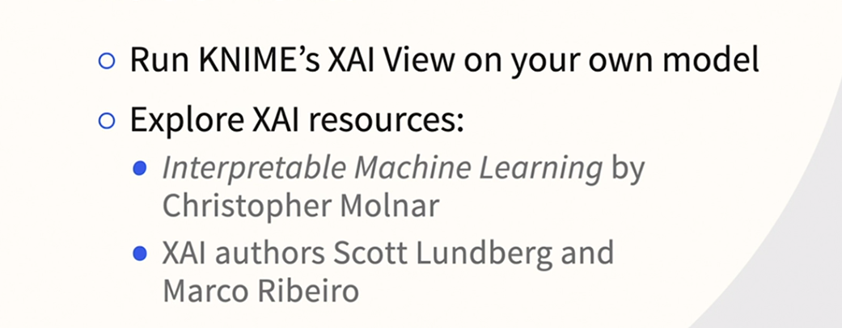

### **Developing an intuition for Shapley values**

Selecting transcript lines in this section will navigate to timestamp in the video

- [Instructor] Shapley values are a popular way of doing local explanations that originated in game theory, and they're implemented in KNIME. I'd like to illustrate Shapley values with a story. Angela, Bob, and Charles all just attended an event at Lincoln Center, which is the Upper West Side of New York City. By the way, numerous Shapley taxi examples use names that start with A, B, and C, so we're keeping with the convention. But rather than just simply imagining that they're traveling in a straight line, that makes the math easier, by the way, we'll put them in a fictional situation where it actually makes sense that they're traveling in a straight line. They all have to head to either midtown or downtown. The math won't be identical to what's going on inside of KNIME, but close enough to give you a good intuition for how this works. Just remember the following while you're listening to the example. Rather than trying to figure out how to divide up the taxi fare, in machine learning, we're trying to divide up the relative contribution of each variable. So since they all need to go somewhere near Broadway, they jump in a cab together, and they start heading south. Charles is studying game theory at NYU, so they all agree to let Charles pay the entire tab, and then later he's going to use Shapley values to figure out the fairest way to divide up the cost. Angela needs Penn Station, so she's going to get out at Broadway and 34th. The taxi meter says $15. So should she give Bob and Charles the whole $15 that she would have paid, or should she give them $5 or some other amount? Bob has to go to Tribeca, so he gets out at Broadway and Canal. The meter now says $35. Bob and Charles are chatting as they go, and they also figure out that an added complication is that the tip is going to be paid by the last person in the taxi. Charles rides all the way down to Wall Street. The meter says $50, and he gives a $10 tip. So the total is $60. 1/3 of that total would be $20, which doesn't seem fair to Angela, so there must be a different solution. Let's break it down. If they were traveling alone, Angela would pay 18, Bob 42, and we know that Charles paid 60. And this is exactly how it works in Shapley value calculations. In addition to the three scenarios, we also have four scenarios where they travel together. What Shapley values do is average across all these scenarios. We're not going to do the math step-by-step. It's not necessary to develop an intuition for how Shapley values are going to work in KNIME. This is going to be enough. But briefly on these so-called coalitions, Ann and Bob would pay 42 'cause they'd have to get to Tribeca, and any time that Charles is involved, the amount is going to be $60 'cause they have to get all the way down to Wall Street. The good news is we don't have to do any math at the moment because there's this wonderful website I found called shapleyvalue.com, and it's going to do the calculations for us. So the value of the coalition with nobody in the cab is $0. And then you'll notice that all of these numbers are numbers that we just talked about, $18 for Angela, $42 for any ride that involves Bob that stops in Tribeca, and $60 for any ride that involves Charles. And we click on Compute, which I've actually already done. And over on the left-hand side, you can see that Angela should pay 6, Bob 18, and Charles 36. I hope you found that fun, but also helpful in trying to understand what KNIME is doing when it's figuring out the contribution, not of the three friends, but of all the variables in your model. But keep in mind, if you had 20 or 50 or 100 variables, this would get complicated real fast. So this is an easy way to develop just an intuition for what Shapley values are all about.

### **Introducing SHAP**

Selecting transcript lines in this section will navigate to timestamp in the video

- [Instructor] While Shapley values have been borrowed from game theory, there is a much younger concept based on Shapley values but that was specifically developed for XAI SHAP. First, the acronym, it stands for shapely additive explanations and was proposed by Scott Lundberg and his co-authors. We don't need to get deep into the math. For our purposes, it will be sufficient to review just a couple of high level points. First, an explicit goal of SHAP is to try to perform these calculations faster. The Shapley value algorithm is not very scalable. Next SHAP **attempts to explain the delta or difference between a case and a base rate.** Remember that we are using SHAP for local explanations. So we're not trying to explain the whole model. So what we care about is explaining how each variable moves a particular case higher or lower than the group. We're trying to answer, for instance, why Anne's credit risk might be lower than the average credit risk. Next, the contributions are additive. Some inputs will bring Anne's risk higher and others will bring her risk lower. But when you add them all up we should return earn to that delta value. The difference between her risk and the baseline risk. One caution, there's more than one kind of SHAP. We'll only be discussing SHAP as it's supported in nine. But if you get deeper into the subject you'll find that there's more than one flavor of it out there. That's just a quick overview, but that will be enough to help you interpret SHAP values in nine.

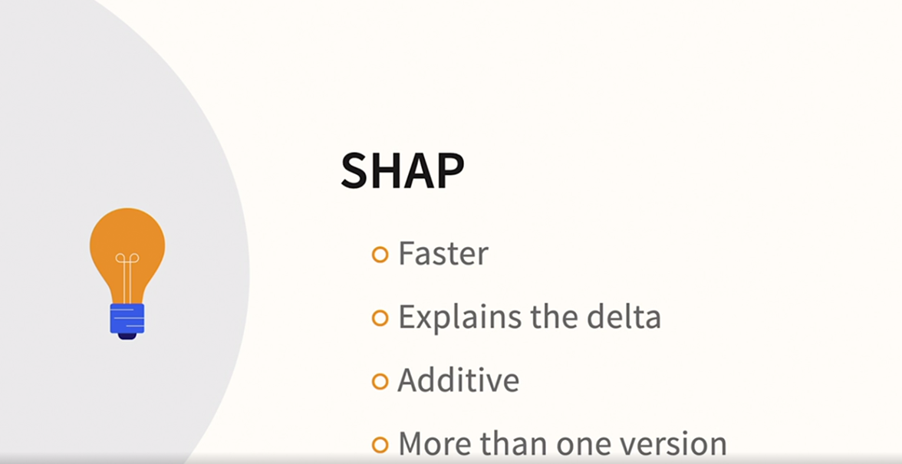

### **Using LIME to provide local explanations for neural networks**

Selecting transcript lines in this section will navigate to timestamp in the video

- [Instructor] Our next technique, LIME, is also quite new and specifically developed for XAI. The acronym stands for Local Interpretable Model-Agnostic Explanations. LIME was developed by Marco Rivera and his coauthors. The concept is more important than the math at this point. So let's review the logic behind LIME. First, it's safe to assume that you felt you needed a complex model. To be clear, LIME is model-agnostic. So the approach can be used with any model, but if you found a way to build a simpler model, presumably you would have just deployed the simpler model. So if you felt forced to go with a rather complex model, let's say a very large and deep decision tree. How were you going to build a simple surrogate that is faithful, to use a phrase that the authors often use, faithful to the original? Well, here's the solution that the authors came up with. Don't try to build a surrogate globally, build a surrogate locally. Concentrate only on cases near and thereby similar to the case that you're trying to describe. LIME samples nearby cases, then weights closer cases more heavily. Remember, we are doing local explanations, so we're focused on a single target case. Closer cases simply means closer to the case we're trying to explain. Another reason that the concept is more important than the algorithmic details, is that there's more than one way to do this. For instance, as we shall see, NIME's local explanation view also samples near the target case, but defines this local neighborhood using a slightly different algorithm than LIME. Nonetheless, LIME and the concept behind it has become one of the most influential and frequently mentioned local explanation techniques in XAI.

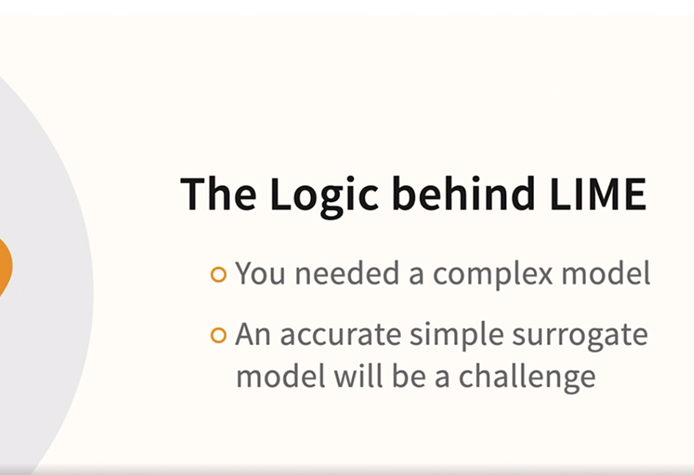

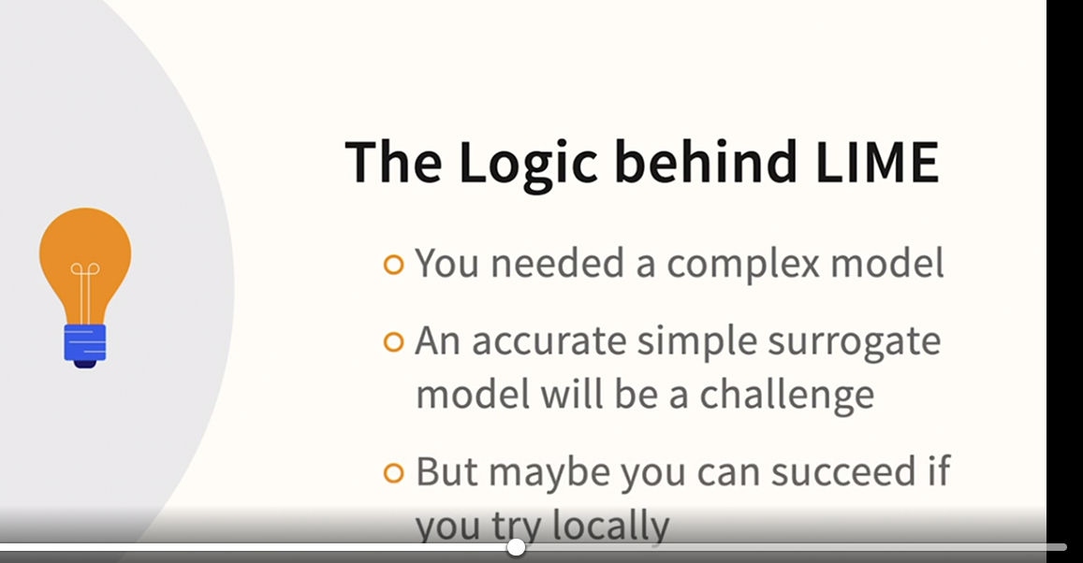

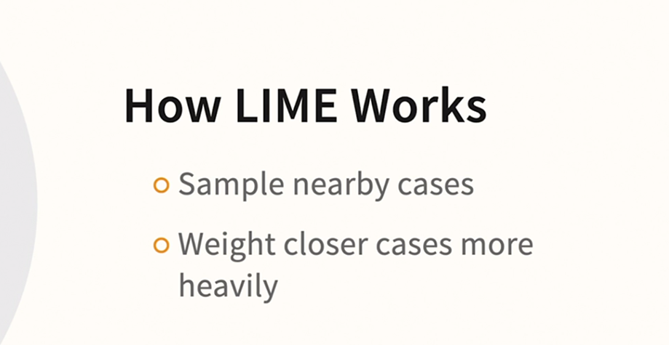

### **What are counterfactuals?**

Selecting transcript lines in this section will navigate to timestamp in the video

- [Instructor] There's a scene from the old TV show, "The Beverly Hillbillies" that I saw as a boy that I still remember. It was about Granny's Common Cold Cure. It struck me as very funny back then, even though I certainly wasn't thinking about XAI or machine learning. Now the memory of it makes me smile because it reminds me of one of the challenges in machine learning. How do you prove that a factor caused or at least influenced an outcome? Here's the instructions for Granny's cure. Take one dose of the cure, eat sensibly, get lots of rest, drink plenty of water, do all that, and according to Jed, in a week to 10 days, your cold will be gone. I think we can all see the humor in that, even if you don't think it's quite as funny as I did as a kid. But how does that relate to XAI? Well, her common cold cure might be habitually present whenever Granny gets a cold, but I don't think any of us really believe that there's a causal relationship there. You could remove Granny's cure, and you would still be fine in seven to 10 days if the diagnosis was a common cold. The famous computer scientist Judea Pearl uses a similar example to Granny's cure in his book, "The Book of Why." "Data can tell you that the people who took a medicine recovered faster than those who did not take it, but they can't tell you why. Maybe those who took the medicine did so because they could afford it and would have recovered just as fast without it." This is what Judea Pearl calls a counterfactual, a what if. But what is a counterfactual in our context, in the context of XAI? It's an attempt to calculate how the target prediction might change if one of the input values changes. We saw this kind of thing in our visit to the credit simulator website earlier in the course. So for XAI, it's a way of getting at local impact. The loan was denied, but if the number of late pays was just one fewer, it would have been approved. NIME has an approach for generating counterfactual information, which we will be seeing in our demonstration of the local explanation view node.

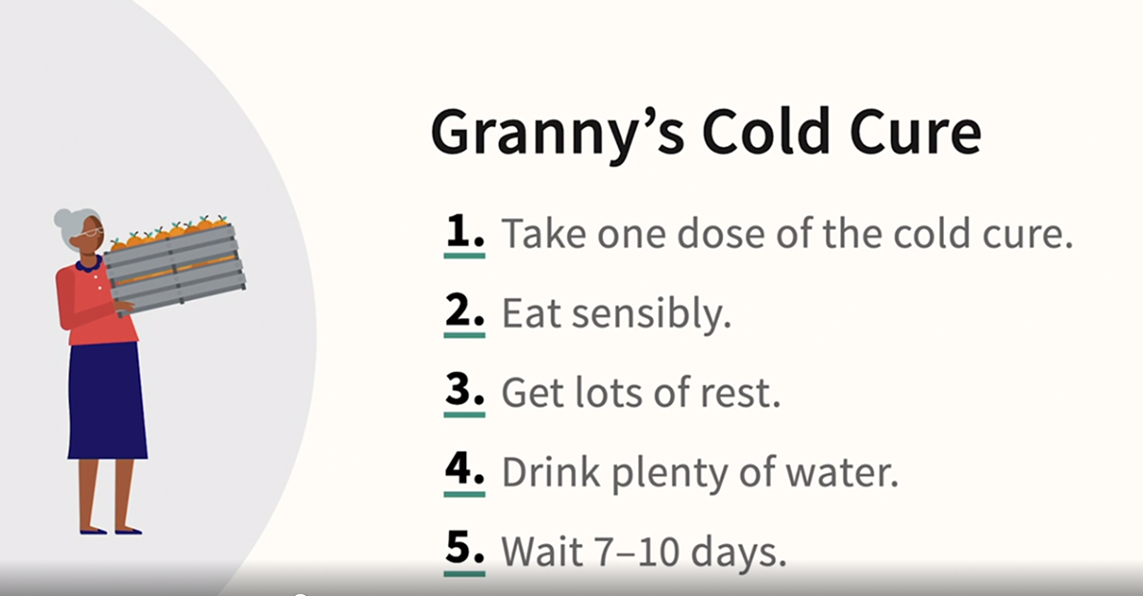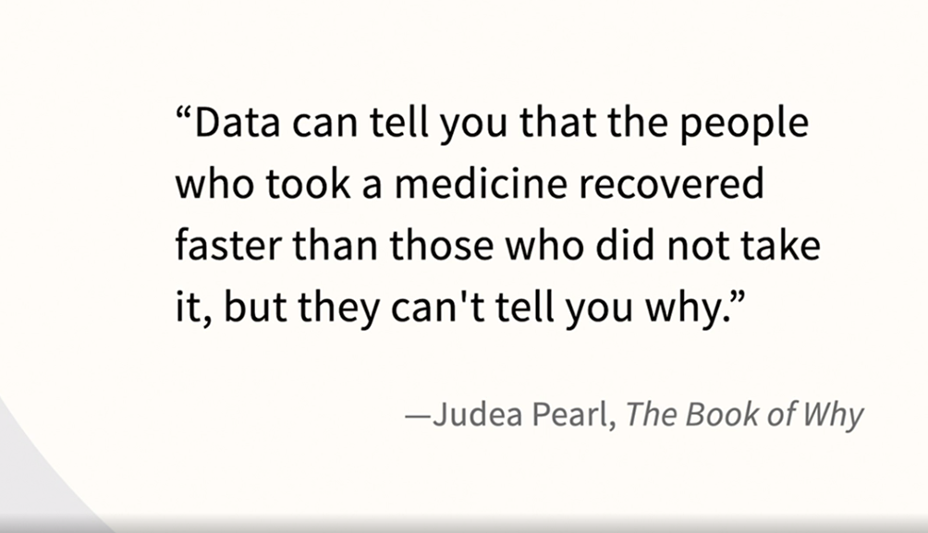

### **KNIME's Local Explanation View node**

Selecting transcript lines in this section will navigate to timestamp in the video

- [Instructor] The team at Knime really tries to make it easy to learn new features. In almost every instance when a new feature comes out, you can count on eventually having a blog post, a practice workflow, and discussion. So you can see here that they have a feature called the Local Explanation View. I've downloaded the relevant workflow and you can too simply by going to the Knime hub and either finding the workflow or the blog post, everything is cross-referenced. Here we are in Knime, and here's the workflow, it's called, this is their numbering now: XAI Credit Scoring Example Local Explanations View. And we can make this a little bit bigger by looking only at that screen. And then let's see if we can fit 125%, which we can. So we're bringing in the credit scoring data. I just want to point out one particular issue of this workflow before we look at the local explanation view. And that is that there's a row sampling node here. And the reason that that's important is, remember that we're doing local explanations. So you're not doing this on the whole data set, you're trying to do this for a particular case which is what we're doing here. So now let's go into the local explanation view. I will enter the interactive view and there's basically three pieces of information to attend to. One is that since we're looking at an individual data point, we have the information for that individual data point here. They're 46 years old, they have one instance of time in debt for one to two months, they have a debt ratio and income and so on listed here. So we're talking about one individual. Then let's go over to local feature importance. Now, as we know, one of the most famous ways of doing this is Lyme. What the Knime folks have done is similar to Lyme but they're defining what they refer to here as the neighborhood of similar data points just a little bit differently but we're accomplishing the same thing. So we can see which things are increasing and decreasing risk. So other active loans is a positive factor for this individual, that instance where they did have times in debt for one to two months is working against them. We also have counterfactuals. So this particular individual was denied the loan but here are individuals that are as close as possible to that original person, essentially nearest neighbors. So we have these individuals that are close to that individual, but that are deemed credit worthy. So now we can see what values did they have that were different. Notice for instance that in all three instances, the ones that are visible, let me maximize this. We can see this larger now. And we can see that in all three instances, times in debt for one to two months is zero. So it's all starting to come together because we know this individual was declined. We know from the Lyme like analysis that times in debt for one to two months is an important factor. And now we're learning from the counterfactuals that the individuals that were credit worthy that are otherwise similar to this individual have a zero for that value. One final quick comment will actually notice that by default, Knime is providing five counterfactual cases but only three of them fit by default. So I think that they've really done a great job, essentially giving you one stop shopping for some techniques that you would want to use for your local explanations.

### **XAI View node demonstrating KNIME**

Selecting transcript lines in this section will navigate to timestamp in the video

- [Instructor] We're back in KNIME, but with a new workflow. Now that we've seen the Global Explanation View earlier in the course and just seen the Local Explanation View, now we're going to take a moment to take a look at a new view, the XAI View that combines elements of local and global. This can be found on the KNIME Hub, and you can see here that its name is 05. Now, that is their numbering convention, 05_XAI_Credit_Scoring_Example_XAI_View. So one quick note before we zoom into the report itself, notice that there's a note here, "Scatter Plot Selection." That's selecting a group of applicants, a small group as it were, because the XAI View, since it combines both local and global features, we don't want to throw the whole data set at it, we want to select a handful. So we're going to have one individual that was declined, or rather that has high risk, and we'll have five that were deemed creditworthy. Let's take a closer look by right-clicking and go into Interactive View. We get a chance to revisit some topics that we've seen earlier in the course. partial dependence plot, but with a new feature, and then we have a bubble chart and a violin chart, and I'm going to talk about each of these in turn. Let's start with the partial dependence plot. I'm going to go ahead and maximize that, but I want to show you how you can change the variable in this report. So we're going to go to the upper-right, and rather than going with Debt-to-Limit Ratio, let's go with one that we know is one of the most important, which is Times in Debt for 1-2 Months. So the difference here, we want to attend to this blue region, which is a bit thin but that represents the overall pattern. Remember, we talked about partial dependence plots when we were talking about global explanations. So these additional lines, there are five green and one red, these additional lines are getting at the trend for the individual cases that we're looking at in this report, so they're looking at things locally. The main thing you want to focus on is, is there a departure from any of those cases from the overall trend? And I detect that for the most part, each of our six individuals has a similar trend line to the overall. If there were dramatic differences, that would be indicative of a variable interaction. So let's go back to the other parts of the report, and we can do that using this button here, the X button goes back to the main report, and let's take a closer look at the bubble chart. Okay, so why five green bubbles and one red bubble? Well, that's the one individual that's been deemed risky and the five that have been deemed creditworthy, so we're talking about just six individuals in this plot. The y-axis is the delta between the individual's creditworthiness and the average creditworthiness. You might recall that that's key to how SHAP works, and that's the purpose of this chart is to show us SHAP. But let's go again to where we can choose variables and choose not Debt-to-Limit Ratio on the x, but that one that we know to be important. Okay, and we can see a pretty big difference. In fact, it's interesting actually that one of the individuals that was creditworthy actually has an instance of this. They have a value similar to the red circle, but they must have other variables that are compensating for that, because overall, they are deemed creditworthy, but we can certainly see that this variable has a big impact on that because the red circle is clearly in a different place in the plot than the others. Remember that the y-axis is getting at that delta, and the impact that the input variable, in this case, Times in Debt for 1-2 Months has, and clearly the red circle is well below zero. So it's really moving that red circle lower and is a major contributor to why they were deemed risky. Let's go back to the main report, and now the violin plot. This is much more looking at things in a global way. There are actually very little circles that indicate our individual cases, but it's the overall pattern that's striking here. So when you have a variable like Debt Ratio over here on the left that's compressed with a low variance around zero, that's indicating to you that that variable can't have a very, very big impact because everybody is close to zero, either a bit above or a bit below. In contrast, if you look at some of these other variables like the orange variable here, monthly income, or the yellow variable, the one that we knew is important and that we've looked at twice before in this report, Times in Debt for 1-2 Months, we have this huge variance with some cases going well above zero and other cases well below. So when you look at this violin plot and you have very high variance like the yellow variable, you know that that's a really important variable. And when you have very low variance like the purple variable, you know that that's a much less important variable. So we can go back to the main report and we're not done yet, because we also see a surrogate decision tree here. We can maximize this, and we saw surrogate models earlier in the course, but this report is going ahead and providing that along with others, and we can expand the tree and really get a thorough sense of what variables are prompting our risk to go up and what variables are prompting our risk to go down. I won't discuss it in additional detail since we had a discussion of surrogate earlier, but this report is really great because it gives you not only partial dependence plots but those individual lines which are called ICE, the bubble chart, the violin chart, and finally, the surrogate decision tree.

## **Question 1 of 6**

When applying Shapley values to machine learning models, you are trying to assess the contribution of each _____.

* case
* variable  
  Correct  
  Shapley values help to indicate which variables contribute the most (and least) to the model's prediction.
* algorithm
* model

## **Question 2 of 6**

How are PDP and ICE plots different?

* PDP are global, and ICE plots are local.  
  Correct
* PDP are local, and ICE plots are global.
* PDP consist of multiple lines, and ICE plots consist of single lines.

## **Question 3 of 6**

What kind of model does LIME attempt to fit locally to explain an individual case?

* a random forest  
  Incorrect
* a polynomial
* a neural net
* a linear model  
  Correct  
  The whole point of LIME is to fit a simpler model to a small local area near the case.

## **Question 4 of 6**

What is one way that SHAP is different from Shapley values?

* SHAP is always positive.  
  Incorrect
* SHAP is faster.  
  Correct  
  SHAP is faster and designed to be scalable.
* SHAP is always negative.  
  Incorrect
* SHAP is slower.

## **Question 5 of 6**

Which cases are shown in the Local Explanations View?

* only those that are creditworthy
* only those that are credit risks
* all cases
* a single case at a time  
  Correct  
  The purpose of a local view is to show information about a single case.

## **Question 6 of 6**

What would be evidence that a "common cold cure" worked?

* When the cold cure was used, the cold lasted 10 days or fewer.  
  Incorrect
* A placebo group was given flavored water, and their colds lasted 10 days or fewer.  
  Incorrect
* When the cold cure was not used, the cold lasted longer. When the cold cure was used, the cold lasted less time.



Replay

Review this video

What are counterfactuals?

2m 27s

To,

Father Bala,

Archbishop House,

Nagpur, Maharashtra

Subject : Regarding Scholarship

Respected Sir,

I am Rachell Rajesh Pandey, I have applied for a B.Ed course in Navpratibha College, Nagpur. My financial condition is not allowing me to continue my further studies so I request you to kindly grant me a scholarship.

For this I shall be very grateful to you. Looking forward for reply.

Date: 1 September 2022 Your Truly

<Apna nam>

<Apna Signature>